DESIGN AND IMPLEMENTATION OF A BLOCKCHAIN FOR E-VOTING USING NATIONAL IDENTIFICATION NUMBER (NIN)

BY

UGBAH-NDUKA DAVID KING
BHU/22/04/05/0078

A PROJECT DOCUMENTATION SUBMITTED TO THE DEPARTMENT OF COMPUTER SCIENCE, FACULTY OF COMPUTING,
BINGHAM UNIVERSITY KARU, NASARAWA STATE NIGERIA

IN PARTIAL FULFILMEMT OF THE REQUIREMENTS OF THE AWARD OF BACHELOR OF SCIENCE (B.Sc.) DEGREE IN COMPUTER SCIENCE

DECEMBER, 2025
DECLARATION
I, UGBAH-NDUKA DAVID KING with the Matriculation Number BHU/22/04/05/0078 declare that this Project was carried out by me and every other external work used in this report has been fully acknowledged.

…………………………. ……………………
BHU/22/04/05/0078 DATE
UGBAH-NDUKA DAVID KING

CERTIFICATION
This is to certify that this project was written by UGBAH-NDUKA DAVID KING with
Matric Number BHU/22/04/05/0078 and submitted to the Department of Computer Science, Faculty of Computing, Bingham University, Karu, Nigeria, as part of the requirements for the award of Bachelor of Science (B. Sc.) in Computer Science.

____________________________ ____________________________ Mr. Nathan A. Zoakah DATE Supervisor

____________________________ _____________________________ Dr. Adamu S. Usman DATE Head of Department

____________________________ _____________________________ DATE External Examiner

ACKNOWLEGEMENTS
I wish to express my sincere appreciation my supervisor Mr. Nathan Ayuba Zoakah for the guidance, inspiration and continuous support during this period of my Final Year.
I would like to thank the Dean of the Faculty of Computing and HOD of Department of Computer Science Dr. Adamu S. Usman. My profound gratitude goes to the Lecturers in the Department of Computer Science which include Dr. Yakubu Aliyu Ibrahim, Mrs. Oluwatoyin Adelakun Adeyemo, Mr. Maikori Ezekiel Jenome, Mr. Barka T. Fori, Mr. Emmanuel Dauda and Mr. Nathan Zoakah. A special thanks to all the Lecturers in Faculty of Computing which include: Head of Information Technology Dr. Anah Hassan Biljik, Head of Cyber Security Dr. Oluwasegun Ishaya Adelaye, Dr. Onu Egena, Dr. Victor E. Kulugh, Mr. Musa Yusuf, Mr. Ibrahim Lawal Mrs. Adelaiye A. Nancy. I also thank the Technologists in the Faculty which include: Mr. Joseph Oladele Aremu, Mr. Ngale Langthong and Mr. Sharack Akoh. I also appreciate the Faculty Officer, Mrs. Ajibade Blessing, the Departmental Secretary Mrs. Chioma Godsfavour and the Faculty Clerical Officer, Madam Mary Madaki. A big thank you to all the Teaching and Non-teaching Staff of the Faculty of Computing, Bingham University.
I would like to thank my loving parents Mr. and Mrs. UGBAH-NDUKA for giving their support Financially, Morally, Emotionally and Spiritually. Also, I say thank you to my beloved siblings for being there for me always. I thank my fellow Students from the Department of Computer Science for their support and logical contributions in the various parts of my project.
Finally, I appreciate everyone whose name were not mention but has in one way or the other contributed to the success of this project. May Almighty God bless them all.

DEDICATION
This research work is dedicated to Almighty God the source of my knowledge and creator of the universe. I also dedicate this project to my loving parents Mr. and Mrs.
UGBAH-NDUKA, and to my beloved siblings.

TABLE OF CONTENTS
CHAPTER ONE 1
INTRODUCTION 1
1.1 Background of Study 1
1.2 Statement of Problem 2
1.3 Research Questions 2
1.4 Aim and Objectives of the Study 3
1.5 Significance of the Study 3
1.6 Scope of the Study 4
1.8 Expected Outcome 4
1.9 Organization of the Study 5
CHAPTER TWO 6
LITERATURE REVIEW 6
2.1 Introduction to the Research Topic 6
2.2 Historical Context of the Research Topic 6
2.2.1 Theoretical Frameworks 7
2.3 Key Concepts and Definitions 8
2.4 Methodologies and Research Designs 9
2.5 Empirical Studies 10
2.6 Conceptual Frameworks 11
2.7 Debates and Controversies 11
2.10 Practical Implications 14
2.11 Related Works 15
CHAPTER THREE 18
SYSTEM DESIGN AND METHODOLOGY 18
3.1 Research Approach 18
3.2 Research Design 18
3.3 Software Development Methodology 19
3.3.1 Adopted Methodology 19
3.4 Methodology: Tools and System Architecture 20
3.5 Research Timeline and Evaluation 21
3.6 Data Analysis and Evaluation Plan 23
3.7 Validity and Reliability 23
3.8 System Design and Methodology for Software Development 24
3.8.3 System Modelling 28
3.8.4 System Requirements 33
3.8.5 Database Schema Design 36
REFERENCES 38

v

LIST OF TABLES

Table 2.1: Review of Related Works ...................................................................................... 15
Table 3.1: Research Timeline and Activities .......................................................................... 21
Table 3.2: Functional Requirements ...................................................................................... 34
Table 3.3: Non-Functional Requirements .............................................................................. 35

vi

CHAPTER ONE

INTRODUCTION

1.1 Background of Study
Elections form the foundation of democratic governance, enabling citizens to choose leaders and influence public policy. However, traditional voting methods in Nigeria face serious challenges that undermine electoral credibility and public trust. During the 2023 general elections, the Bimodal Voter Accreditation System (BVAS) experienced failures in approximately 14% of polling units, causing delays, voter disenfranchisement, and voting suspensions (Ene Obi, 2023; olufemiajasa, 2023). Additional problems included late poll openings, missing materials, vote buying, ballot-box snatching, violence, and failure to upload results (Ene Obi, 2023).
Electronic voting (e-voting) systems offer digital platforms for casting, counting, and transmitting votes efficiently. E-voting aims to improve efficiency, enhance transparency, reduce human error, and strengthen public confidence in electoral outcomes (Adesiyan, 2023). Estonia successfully implemented internet-based voting in 2005 using national ID cards for secure authentication, demonstrating that digital platforms can increase efficiency whilst maintaining security (Fabian Breuer and Alexander H. Trechse, 2006; David Mac Dougall, 2023).
However, conventional e-voting systems face significant limitations. Centralized architectures are vulnerable to cyberattacks, data manipulation, and limited auditability. Poor infrastructure, inadequate training, and connectivity issues further compromise effectiveness in Nigeria (Ene Obi, 2023).
Blockchain technology addresses these limitations through decentralized distributed ledgers that ensure immutability, transparency, and tamper-resistance. Blockchain-based e-voting systems enable verifiable vote records, prevent double voting, preserve voter anonymity, and provide auditable election trails (Russo et al., 2021; Ohize et al., 2024).
Integrating blockchain e-voting with Nigeria's National Identification Number (NIN) strengthens voter authentication and reduces impersonation. The NIN, issued by the National Identity Management Commission (NIMC), provides unique identifiers for Nigerian citizens, enabling secure voter verification (Adesiyan, 2023).
This study designs and implements a blockchain-enabled e-voting platform linked to NIN to address Nigeria's recurring electoral challenges including technical failures, authentication issues, and public mistrust in the Independent National Electoral Commission (INEC). The system aims to enhance the integrity and reliability of Nigerian electoral processes (Ene Obi, 2023; Adesiyan, 2023).

1.2 Statement of Problem
Elections in Nigeria are central to democratic governance, yet persistent challenges undermine their credibility. During the 2023 general elections, approximately 14% of polling units experienced failures in the Bimodal Voter Accreditation System (BVAS), leading to delayed voting, disenfranchisement, and suspension of voting at affected units (Ene Obi, 2023). Election observers reported missing materials, late opening of polling units, ballot-box snatching, intimidation, and failure to upload results for multiple locations (Ene Obi, 2023; olufemiajasa, 2023).
While electronic and biometric systems like BVAS have been introduced to improve efficiency and transparency, centralized architectures remain vulnerable to technical failures, manipulation, and limited auditability. Connectivity issues, power outages, and human error continue to compromise system reliability (Adesiyan, 2023).
Despite these interventions, no existing blockchain-based system integrated with the National Identification Number (NIN) exists in Nigeria to ensure secure, verifiable, and tamper-proof elections. This gap highlights the need for an innovative solution combining decentralized ledger technology with NIN authentication to guarantee transparency, auditability, and trust in electoral outcomes. This study designs and implements a blockchain-enabled e-voting system using NIN to address these systemic deficiencies and enhance the integrity of future Nigerian elections (Russo et al., 2021; Ene Obi, 2023).

1.3 Research Questions
Based on the recurring failures of Nigeria's electoral system and the limitations of current electronic and biometric voting technologies, this study addresses the following research questions:
- How can a blockchain-based system be designed to ensure secure, verifiable, and tamperproof e-voting in Nigeria?
- In what ways can integration with the National Identification Number (NIN) enhance voter authentication and prevent impersonation?
- What are the technical and operational challenges of implementing blockchain-enabled evoting in the Nigerian electoral context?
- How can the proposed system improve transparency, auditability, and public trust compared to existing electronic voting solutions?

1.4 Aim and Objectives of the Study
The aim of this study is to design and implement a secure, transparent, and verifiable blockchain based e-voting system that integrates Nigeria’s National Identification Number (NIN) for efficient voter authentication and election integrity. The Objectives of the study are to;
- Analyze the limitations of existing electronic and biometric voting systems in Nigeria.
- Design a blockchain enabled e-voting architecture that ensures immutability, auditability, and secure vote recording.
- Integrate/ simulate the system with NIN for robust voter authentication and prevention of impersonation. iv. Implement the designed system and conduct functional testing to ensure reliability and security.
v. Evaluate the system’s performance and compare it with existing electronic voting solutions in terms of transparency, efficiency, and user trust.

1.5 Significance of the Study
The significance of this study lies in its potential to enhance the credibility, transparency, and efficiency of elections in Nigeria. By designing a blockchain-based e-voting system integrated with the National Identification Number (NIN), the study aims to:
i. Reduce electoral fraud and prevent voter impersonation through secure digital voter authentication. ii. Improve public trust in the electoral process by ensuring verifiable and tamper-proof vote records.
- Provide a framework for transparent and auditable elections that can minimize disputes and delays in result collation.
- Offer insights and a practical model for policymakers, electoral bodies, and researchers interested in secure and technology-driven voting systems.

1.6 Scope of the Study
The scope of this study is limited to the design and implementation of a blockchain-based e-voting system integrated with Nigeria's National Identification Number (NIN) for secure voter authentication. The study focuses on:
- Development of a Digital Voting Platform: Designing a user-friendly interface that allows registered voters to cast ballots securely from digital devices.
- Blockchain Implementation: Integrating a decentralized ledger to ensure votes are immutable (cannot be changed), transparent (viewable by authorized parties), and auditable (verifiable for accuracy).
- NIN Integration: Creating an authentication layer that communicates with the NIN database (or simulated version) to verify voter identity and prevent multiple voting or impersonation.
- Performance Testing: Evaluating the system in a simulated environment to measure transaction processing speed (performance), attack resistance (security), and system uptime (reliability).
Out of scope:
- Nationwide deployment across all polling units.
- Legal, political, and policy adoption processes.
- Physical hardware procurement, maintenance, or on-site election logistics.

1.8 Expected Outcome
The expected outcome is a fully functional blockchain-based e-voting system where eligible voters authenticate using their National Identification Number (NIN), securely cast votes, and have votes recorded immutably on a blockchain network. The system will provide secure voter verification, transparent vote storage, and automated vote tallying through smart contracts. A comprehensive project report documenting the system's design, architecture, implementation, and testing will be produced.

1.9 Organization of the Study
This research is organized into five chapters:

Chapter One: Introduction
Presents the background, problem statement, aim and objectives, significance, scope, and definition of terms. It establishes the foundation for understanding why a blockchain-based evoting system integrated with NIN authentication is necessary.

Chapter Two: Literature Review
Reviews relevant theoretical and empirical literature, examining existing electronic voting systems, blockchain technologies, biometric authentication methods, and previous studies integrating NIN or similar national identity systems for secure voting.

Chapter Three: System Design and Methodology
Describes the research methodology and system architecture, outlining system requirements, flowcharts, UML diagrams, blockchain model (consensus mechanism, ledger structure), and NIN verification process. It details the tools and technologies used for development.

Chapter Four: Implementation and Testing
Presents the practical implementation including development environment, user interface design, backend logic, smart contract deployment, and NIN authentication integration. It includes functional and non-functional testing, performance evaluation, and security validation.

Chapter Five: Summary, Conclusion, and Recommendations
Summarizes the entire work and discusses how the system meets stated objectives. It provides conclusions on the effectiveness of the blockchain-based e-voting model and offers recommendations for future enhancements, policy adoption, and further research.

CHAPTER TWO

LITERATURE REVIEW

2.1 Introduction to the Research Topic
Electoral integrity remains a critical challenge in developing nations, where vote manipulation, fraud, and lack of transparency undermine public confidence in democratic processes (Kshetri & Voas, 2018). Blockchain-based e-voting systems offer a solution by leveraging blockchain's key features decentralization, immutability, transparency, and cryptographic security to create tamperresistant voting infrastructures that can be audited by multiple stakeholders (Hjálmarsson et al., 2018).
Integrating Nigeria's National Identification Number (NIN) adds a crucial layer of identity verification. This ensures "one person, one vote" by preventing duplicate registrations and voter impersonation (Yaga et al., 2019). This research combines blockchain technology for secure vote recording with NIN-based authentication to create a verifiable electoral platform.
The system addresses Nigeria's specific challenges, manual vote counting across dispersed polling units, electoral malpractices like ballot stuffing, and the need for secure yet inclusive voting mechanisms (Adeniji & Olaosebikan, 2020). By enabling real-time vote counting and verification, the system can enhance electoral credibility, reduce disputes, and restore citizen confidence that votes are accurately recorded without manipulation (Pawlak et al., 2018).

2.2 Historical Context of the Research Topic
Electronic voting systems have evolved through several distinct phases over five decades. Traditional paper-based voting relies on manual counting and physical ballot boxes, making it vulnerable to manipulation, human error, and logistical challenges (Gritzalis, 2002). The first generation of electronic voting emerged in the 1960s with direct recording electronic (DRE) machines using push buttons or touch screens. However, these systems lacked verifiable paper trails and raised concerns about result manipulation (Mercuri, 2002).
The 1990s introduced internet-based voting systems. Estonia implemented remote e-voting for national elections, but these centralized systems remained vulnerable to server attacks and lacked transparency (Springall et al., 2014). The breakthrough came in 2008 when Bitcoin introduced blockchain technology, demonstrating how distributed ledgers could create tamper-resistant records without central authority (Nakamoto, 2008). Researchers began exploring blockchain for voting in the early 2010s, recognizing its potential to address electoral integrity challenges (Ayed, 2017).
The first blockchain voting trials occurred between 2016-2018 in Switzerland, South Korea, and Sierra Leone, though these implementations faced scalability and usability challenges (Hjálmarsson et al., 2018). In Nigeria, the National Identity Management Commission (NIMC) launched the NIN system in 2014, creating the infrastructure necessary for digital identity verification in e-voting (NIPC, 2020). Recent research focuses on integrating biometric authentication with blockchain voting to strengthen identity verification while maintaining ballot secrecy (Alam et al., 2021). Challenges around voter privacy, accessibility, and regulatory frameworks continue to drive ongoing research.

2.2.1 Theoretical Frameworks
This research applies several established frameworks from information security and democratic systems. The CIA Triad (Confidentiality, Integrity, Availability) provides foundational security principles (Stallings & Brown, 2018). Confidentiality ensures votes remain secret and cannot be linked to voters. Integrity guarantees votes cannot be altered after submission. Availability ensures eligible voters can access the system during voting periods.
The Defense-in-Depth model informs the multi-layered security approach. Blockchain immutability, cryptographic encryption, NIN authentication, and smart contract validation function as complementary layers protecting against different attack vectors (Scarfone & Mell, 2007). The Zero Trust Security model requires continuous verification throughout the voting process rather than relying only on initial login (Rose et al., 2020). Voters authenticate using NIN before accessing ballots, votes are cryptographically signed to prevent tampering, and blockchain nodes independently verify each transaction. These frameworks guide the system architecture towards comprehensive security while maintaining ballot secrecy and electoral transparency.

2.3 Key Concepts and Definitions
- Blockchain: is a distributed ledger technology that records transactions across multiple computers, making records immutable and transparent. Each block contains a cryptographic hash of the previous block, creating a tamper-evident chain (Yaga et al., 2019).
- Smart Contracts: are self-executing programs stored on a blockchain that automatically enforce predefined rules and conditions, enabling automated vote validation and tallying without human intervention (Zheng et al., 2020).
- Decentralization: describes a system architecture where control and decision-making are distributed across multiple nodes rather than concentrated in a single central authority, reducing single points of failure and manipulation risk (Buterin, 2014).
- Immutability: means that once data is recorded on a blockchain, it cannot be altered or deleted without detection, ensuring votes remain permanent and tamper-proof after submission (Nakamoto, 2008).
- Consensus Mechanism: refers to the algorithm blockchain networks use to achieve agreement among distributed nodes on transaction validity. Common mechanisms include Proof of Work, Proof of Stake, and Practical Byzantine Fault Tolerance, is a system that allows a network to reach a correct agreement even if up to one-third of its members are lying or failing, by having all nodes cross-verify each other's messages in multiple rounds. (Mingxiao et al., 2017).
- National Identification Number (NIN): is a unique 11-digit number issued by Nigeria's National Identity Management Commission to citizens and legal residents, serving as the primary identifier for government services and identity verification (NIMC, 2020). vii. Cryptographic Hashing: uses mathematical algorithms to convert data into fixed-length strings that uniquely represent the original data, enabling vote verification without revealing vote content (Stallings & Brown, 2018).
- Digital Signature: is a cryptographic technique that authenticates the sender of a digital message and ensures message integrity, allowing voters to sign their ballots without revealing their identity (Katz & Lindell, 2014).
- Electoral Integrity: refers to the degree to which elections are conducted fairly, transparently, and according to democratic principles, producing results that accurately reflect voter preferences (Norris, 2014).
- Voter Authentication: involves verifying that a person attempting to vote is eligible and authorized to participate in the election, typically through identity verification mechanisms (Jones & Simons, 2012).
- Ballot Secrecy: ensures that individual votes cannot be traced back to specific voters, protecting voters from coercion and enabling free expression of political preferences (Benaloh, 2006).
- End-to-End Verifiability: means that voters can verify their votes were correctly recorded, counted, and included in the final tally without compromising ballot secrecy (Adida, 2008).

2.4 Methodologies and Research Designs
Research in blockchain-based e-voting systems primarily uses experimental, design science, and case study methodologies. Experimental approaches test blockchain voting platforms to measure transaction throughput, latency, scalability, and security resilience against attack scenarios (Hjálmarsson et al., 2018). These studies compare blockchain implementations against traditional systems or evaluate different consensus mechanisms for optimal configurations.
Design science research focuses on creating and evaluating new blockchain voting architectures for real-world electoral contexts (Kshetri & Voas, 2018). This involves iterative cycles of design, implementation, testing, and refinement based on stakeholder feedback. Case study methodologies examine actual deployments in Estonia, Switzerland, and Sierra Leone, documenting implementation challenges, voter acceptance rates, and operational outcomes (Hao et al., 2020). Mixed-methods approaches combine quantitative performance metrics with qualitative assessments of voter experiences and regulatory compliance (Pawlak et al., 2018).
Data collection methods vary across studies. Some researchers use simulated elections with controlled populations, while others analyze data from pilot deployments or actual electoral events. Proof of Authority (PoA) and Practical Byzantine Fault Tolerance (PBFT) consensus mechanisms are popular choices for voting applications, offering transaction confirmation times under 10 seconds compared to Proof of Work (Shahzad & Crowcroft, 2019). Ethereum and Hyperledger Fabric dominate platform choices due to their mature development tools and extensive documentation.
Evaluation frameworks consider technical performance, security, voter privacy, auditability, accessibility, and regulatory compliance (Springall et al., 2014). Security testing includes penetration testing, formal verification of smart contracts, and simulation of attack scenarios such as double-voting attempts, denial-of-service attacks, and node collusion.

2.5 Empirical Studies
Recent research demonstrates both the potential and challenges of blockchain-based e-voting systems. Bismark et al. (2025) pioneered NIN-blockchain integration in Nigeria, achieving 100% authentication accuracy by separating identity verification from vote recording.
Njoku et al. (2023) used IBM Hyperledger Fabric with NIN authentication, showing that enterprise blockchains offer faster speeds and better privacy control than public blockchains. However, both studies tested only simulated systems without connecting to actual NIMC databases, leaving questions about real-world performance, network delays, and data reliability unanswered.
Jayakumari et al. (2024) tackled scalability by combining cloud computing with blockchain technology, achieving fast transaction times through automated smart contracts. Their cloud-based approach raised concerns about data sovereignty and reliance on third-party providers.
Osayomore et al. (2025) strengthened authentication by adding fingerprint and facial recognition to blockchain voting, demonstrating higher accuracy than NIN-only systems. However, the high costs of biometric hardware and privacy risks of centralized biometric databases pose significant barriers to nationwide deployment.
Steven et al. (2025) explored the Internet Computer Protocol in Indonesia, achieving over 1,000 transactions per second at lower costs than Ethereum. Their real-world implementation revealed important challenges including voter education needs and varying technical literacy across age groups and locations. While valuable, their Indonesian-specific design lacks NIN integration and does not address Nigerian legal requirements, limiting direct application to Nigerian elections.

2.6 Conceptual Frameworks
The conceptual framework for blockchain-based e-voting systems with NIN integration comprises interconnected layers. The identity layer manages voter registration, NIN verification, and biometric authentication to ensure only eligible citizens participate (Kshetri & Voas, 2018). This layer interfaces with Nigeria's National Identity Management Commission database to validate credentials before granting access.
The blockchain layer provides distributed ledger infrastructure where votes are recorded as immutable transactions. Each vote is cryptographically hashed and linked to previous transactions, creating a tamper-evident chain (Yaga et al., 2019). Consensus mechanisms allow network nodes to agree on vote validity without central authority.
The smart contract layer contains self-executing programs that enforce voting rules, validate eligibility, prevent double voting, and automatically tally results (Hjálmarsson et al., 2018). The security layer implements cryptographic encryption for confidentiality, digital signatures for authentication, and access controls separating voter identity from vote content to maintain ballot secrecy (Shahzad & Crowcroft, 2019).
The interface layer provides user-facing applications for voters, election officials, and observers, emphasizing simplicity for varying technical abilities (Risnanto & Imran, 2019). The verification layer enables end-to-end auditability, allowing voters to confirm votes were recorded correctly while preventing identification of how individuals voted (Adida, 2008).
This framework emphasizes modularity for independent component development and testing. Privacy-preserving design includes data minimization, ballot secrecy, and electoral law compliance. The model balances technological capabilities with democratic principles to achieve legitimacy (Norris, 2014).

2.7 Debates and Controversies
Significant debates surround the implementation of blockchain-based e-voting systems in democratic elections. Privacy concerns constitute the primary controversy. Critics argue that digital voting systems inherently create electronic trails that could link voters to their ballot choices, compromising the fundamental democratic principle of secret ballots (Springall et al., 2014). Opponents fear that government authorities or hackers could analyze voting patterns and identify individual voters through transaction metadata, network analysis, or correlation with registration databases.
- Scalability challenges present another contentious issue. Blockchain networks face throughput limitations that may prevent processing millions of votes within short timeframes during national elections (Shahzad & Crowcroft, 2019). Critics point to Ethereum's 15-30 transactions per second as insufficient for large populations, though proponents argue that permissioned blockchains and layer-2 solutions can achieve necessary performance levels.
- Technological accessibility raises concerns that blockchain voting may disadvantage citizens lacking internet connectivity, smartphones, or technical literacy, potentially creating digital divides that exclude vulnerable populations (Khan et al., 2021). With researchers documenting exploitable weaknesses in smart contracts, client-side software, and network infrastructure that could enable vote manipulation despite blockchain's theoretical immutability (Atzei et al., 2017).
- The verifiability paradox creates philosophical tensions. Systems providing strong voter verification may inadvertently enable vote selling or coercion by allowing voters to prove how they voted to third parties (Benaloh, 2006). Regulatory uncertainty presents practical challenges, as most national electoral laws were written for paper-based systems and do not clearly address blockchain voting legality, recount procedures, or dispute resolution (Pawlak et al., 2018).
- Trust in technology versus trust in institutions remains fundamentally contested. Some argue that blockchain's cryptographic guarantees provide stronger assurances than human administered elections, while others maintain that democratic legitimacy requires human oversight that algorithms cannot replace (Norris, 2014). Cost-benefit calculations generate ongoing disagreement, with implementation requiring substantial upfront investments while cost savings materialize only over extended periods (Khan et al., 2021).
- Environmental impact concerns have emerged regarding energy consumption, particularly for Proof of Work blockchains. These controversies have prompted varied regulatory responses globally, with some jurisdictions embracing blockchain voting pilots while others impose strict prohibitions.

2.8 Theoretical Contributions
This research proposes an integrated framework combining blockchain technology with Nigeria's National Identification System to create a secure electoral architecture. The study demonstrates how distributed ledger immutability, cryptographic authentication, smart contracts, and biometric verification function as complementary security layers for democratic elections. By documenting design principles and trade-offs between transparency and privacy, the research provides insights applicable to broader governance contexts.
The work contributes to democratic theory by exploring how technology-mediated voting differs from traditional ballot casting and its implications for political participation and electoral legitimacy in Nigeria. It extends the CIA Triad (Confidentiality, Integrity, Availability) framework by demonstrating its application where these principles must coexist despite inherent tensions, advancing zero-trust security models requiring continuous cryptographic verification.
By examining NIN-based biometric authentication with blockchain anonymity, this research contributes to identity management theory specifically how systems verify identity during authentication while preventing identity linkage during vote recording. The work demonstrates how smart contracts encode Nigerian electoral rules into executable logic.

2.9 Methodological Contributions
Methodologically, this research demonstrates systematic blockchain-NIN database integration while maintaining data sovereignty and privacy compliance. The study contributes methods for implementing ballot secrecy in transparent blockchain systems through cryptographic techniques enabling vote verification without revealing content.
The research presents blockchain optimization techniques through consensus mechanism selection, transaction batching, and scalability strategies. The evaluation framework assesses technical performance, security, usability, and regulatory compliance offering a comprehensive template for blockchain governance systems. The study advances voter privacy protection by evaluating linkability risks, transaction metadata exposure, and anonymity guarantees. It demonstrates hybrid system design combining blockchain immutability with database efficiency, identifying when decentralization is necessary versus when centralized systems suffice.

2.10 Practical Implications
The practical implications of this research extend across multiple stakeholder groups in Nigeria's electoral ecosystem. For the Independent National Electoral Commission (INEC), the study demonstrates the feasibility of implementing a cost-effective blockchain-based voting system that can scale to handle millions of voters across Nigeria's 36 states and Federal Capital Territory without proportional increases in staffing or manual counting requirements. The research provides guidance for electoral bodies considering blockchain adoption, outlining technical requirements, infrastructure needs, and potential challenges specific to Nigerian contexts.
For Nigerian voters, the system offers transparent, verifiable voting that eliminates opportunities for ballot stuffing and result manipulation while ensuring each vote is accurately recorded and counted. Blockchain transparency may increase voter confidence compared to opaque manual counting processes that currently generate frequent disputes. For political parties and candidates, automated vote tallying and real-time result verification reduce opportunities for electoral fraud while providing credible audit trails that can resolve disputes without prolonged legal battles.
For the National Identity Management Commission, the research demonstrates practical applications of the NIN database beyond basic identification, showing how biometric records can strengthen democratic processes while justifying continued investment in national identity infrastructure. For civil society organizations and election observers, the system provides unprecedented transparency through blockchain's public ledger, enabling independent verification of results and strengthening democratic accountability.
For Nigerian policymakers and lawmakers, the research illuminates the capabilities and limitations of blockchain voting technology, informing potential amendments to electoral laws and regulatory frameworks that would enable legal adoption. The study's emphasis on privacy-preserving design and compliance with democratic norms provides practical insights for developing systems that balance technological efficiency with constitutional requirements for free, fair, and credible elections. For technology developers and system integrators, the research provides a practical blueprint for implementing blockchain voting solutions in developing country contexts where infrastructure constraints and diverse user populations require careful design considerations.

2.11 Related Works
A comprehensive review of empirical literature reveals the evolution and current state of blockchain-based e-voting systems integrated with national identity verification mechanisms.
Table 2.1 synthesizes major research contributions, highlighting their methodological approaches, key findings, and limitations. The studies are organized thematically based on core research focus: blockchain architecture, biometric integration, NIN-specific implementations, and security frameworks.
Table 2.1: Review of Related Works
S/N | NAME | TITLE | METHOD | FINDINGS | LIMITATIONS
1 | Bismark et al. (2025) | Development of a blockchain-based electronic voting  system utilizing  NIN | Ethereum blockchain with smart contracts; NIN database verification; local testing | Achieved 100% login authentication; secure, transparent vote recording using NIN verification | Limited to local  testing; nationwide scalability untested; no actual NIMC database integration
2 | Njoku et al. (2023) | Development of an e-voting system using IBM blockchain  technology and  NIN | IBM  Hyperledger  Fabric;  SSADM; NIN  database integration | Web-based platform authenticates users via NIN before blockchain ballot access | Enterprise IBM framework limits cost efficiency; no exploration of gas-efficient blockchains
3 | Jayakumari et al. (2024) | E-voting system using cloudbased hybrid blockchain technology | Hybrid blockchain; smart contracts; timestamp authentication;  PBFT  consensus | Secure, transparent, costeffective voting; automated tallying via smart contracts | Simulation only;  no real deployment; lacks national identity authentication
4 | Dumbre et al. (2025) | Design and implementation of a blockchainbased e-voting system with enhanced voter authentication | Permissioned blockchain; PoA consensus; smart contracts; multi-factor authentication | Secure, tamperproof voting with low latency; automated registration and tallying | Simulation only; real-world deployment untested; no national ID integration
5 | Osayomore et al. (2025) | Blockchain-based e-voting system enhanced with | Blockchain with biometric authentication; | Improved authentication accuracy; | High infrastructure costs; biometric

 |  | fingerprint and facial recognition | SPSS analysis;  SWOT  evaluation | enhanced trust; demonstrated vote immutability | privacy concerns; uncertain nationwide scalability
6 | Ejenarhome et al. (2025) | Evaluation of electronic-based voting system and design (2024 Edo State election) | Blockchain with multimodal biometrics; case study of electoral failures | Decentralized ledgers prevent vote alteration; solution to ballot snatching | Heavy focus on physical hardware; limited NIMC software integration details; scalability unaddressed
7 | Steven et al. (2025) | Implementation of blockchainbased electronic voting system: Indonesia case study | Internet  Computer  Protocol; Azle (TypeScript); facial recognition | Faster, cheaper blockchain using ICP; prevented vote manipulation via  Face ID | Designed for Indonesian context; no  Nigerian NIMC  API integration
8 | Pandey &  Tiwari (2023) | Secure e-voting systems using blockchain technology | Ethereum; smart contracts;  Ganache;  MetaMask;  Web3.js;  Truffle; Mocha | Secure, transparent, anonymous voting; improved onchain verification | High Ethereum gas costs; not tested in live elections; requires technical expertise
9 | Russo et al. (2021) | Chirotonia: A scalable and secure e-voting framework based on blockchains and linkable ring signatures | Blockchain with linkable ring signatures; privacypreserving cryptography | Voter anonymity preserved while preventing double voting; scalable architecture | Complex cryptographic implementation; limited real-world testing; unclear high-load performance
10 | Shahzad &  Crowcroft  (2019) | Trustworthy electronic voting using adjusted blockchain technology | Modified blockchain;  PBFT  consensus; transaction optimization | Transaction confirmation under 10 seconds; trustworthy Byzantine faulttolerant recording | Permissioned blockchain limits transparency; centralized nodes contradict decentralization
11 | Hjálmarsson et al. (2018) | Blockchain-based e-voting system | Ethereum; university election pilot (50 participants) | Demonstrated technical feasibility; validated vote casting and tallying | Small-scale only (50 voters); national scalability concerns; throughput limitations
12 | Khan & Salah (2021) | IoT security: Review, blockchain solutions, and open challenges | Literature review; blockchain security framework analysis | Blockchain enhances data immutability, device authentication, distributed trust  in IoT | Conceptual only; no implementation; scalability and resource demands remain challenges
13 | Hardwick et al. (2018) | E-voting with blockchain: An evoting protocol with decentralization and voter privacy | Hyperledger Fabric comparison; privacy protocols; performance benchmarking | Hyperledger 5-  7x faster than Ethereum; 90% lower energy consumption | Permissioned blockchain limits public audit; complex setup for authorities
14 | Kshetri &  Voas (2018) | Blockchainenabled e-voting | Theoretical analysis; security assessment framework | Blockchain addresses vote tampering, enables transparent auditing, reduces fraud | Theoretical only;  practical deployment challenges unaddressed; regulatory barriers unexplored
15 | Yavuz et al. (2018) | Towards secure e-voting using Ethereum blockchain | Ethereum smart contracts;  homomorphic encryption; prototype | Vote tallying without decrypting individual ballots; preserved voter privacy | High computational overhead; processing time unsuitable for time-sensitive elections

CHAPTER THREE

SYSTEM DESIGN AND METHODOLOGY

3.1 Research Approach
This research employs a mixed-methods approach, combining quantitative and qualitative elements to address the design, implementation, and evaluation of the blockchain-based e-voting system integrated with National Identification Number (NIN) authentication. The quantitative component measures system performance through metrics such as transaction throughput (votes processed per second), authentication accuracy rates, blockchain synchronization latency, smart contract execution time, and system scalability under varying voter loads. Performance benchmarking compares the implemented system against existing electronic voting solutions in terms of vote recording speed, result tallying efficiency, and infrastructure resource consumption.
The qualitative component includes evaluation of user experience through interface usability assessments, voter confidence surveys, and system functionality validation with stakeholders including potential voters, election officials, and technical administrators. User acceptance testing gathers feedback on interface clarity, authentication process simplicity, voting workflow intuitiveness, and overall trust in the system's ability to record votes accurately and securely.
This mixed-methods approach provides a complete understanding of both the technical performance capabilities and practical usability of the developed system, ensuring that the solution addresses Nigeria's electoral integrity challenges while remaining accessible and trustworthy for end users across diverse demographic groups and technical literacy levels.

3.2 Research Design
This research uses experimental design and design science methodology. The study designs, implements, and tests the blockchain e-voting system to evaluate its effectiveness. The research has four stages: architecture design, prototype development, functional testing, and performance evaluation.
The architecture design phase selects the blockchain platform, determines the consensus mechanism, specifies smart contract logic, and establishes NIN integration protocols. The prototype development phase builds core components incrementally: voter registration module, NIN authentication interface, blockchain vote recording mechanism, and smart contract-based tallying.
Functional testing simulates electoral processes including voter registration, authentication attempts (legitimate and fraudulent), vote casting, and result tallying. This verifies the system enforces electoral rules and prevents unauthorized actions. Performance evaluation measures authentication accuracy, transaction processing speed, scalability under voter loads, and blockchain synchronization efficiency. Usability testing with representative voter demographics assesses user experience.
This design validates whether the system addresses Nigeria's electoral integrity challenges while remaining practical and accessible for real-world deployment.

3.3 Software Development Methodology
This project adopts an adapted Agile methodology, specifically Scrum, due to the iterative nature of blockchain smart contract development, NIN integration testing, and the need for continuous security validation and refinement.

3.3.1 Adopted Methodology
An adapted Agile (Scrum) methodology was selected for this project based on several project specific factors:
- Iterative Blockchain Development: Smart contracts for vote recording, authentication, and tallying require continuous refinement. Agile's sprint-based approach enables iterative improvement of security, efficiency, and compliance.
- Evolving Security Requirements: Security vulnerabilities discovered during development require requirement updates. Agile accommodates these changes without complete project restructuring.
- Early Component Testing: Each sprint delivers functional modules (NIN authentication, blockchain vote recording, smart contract execution). This enables early testing before full integration, allowing rapid issue identification and correction.
- Complexity Management: The system is broken into manageable features across sprints:
voter registration, authentication interface, vote casting, and result tallying. This reduces complexity and enables focused development.
- Academic Timeline Constraints: This final year project has strict submission deadlines. Agile sprints ensure consistent progress within the required timeframe.
The Scrum implementation uses 2-week sprint cycles. Each sprint focuses on specific system components. Sprint planning defines objectives and deliverables. Daily tracking monitors progress. Sprint reviews evaluate outputs against acceptance criteria. Sprint retrospectives identify process improvements.

3.4 Methodology: Tools and System Architecture
- Development Stack The system is built on the Ethereum ecosystem. Solidity is used for smart contract logic, while the Truffle Suite and Ganache provide the framework for development, testing, and local blockchain emulation. For the interface, React.js (Frontend) and Node.js/Express (Backend) handle the voter experience and API requests, respectively.
- Authentication and Security To verify identity without compromising privacy, the system integrates the WebAuthn API. This allows for device-level biometric authentication (fingerprint or facial recognition) where sensitive data never leaves the user's device. For data integrity, AES-256 encrypts voter information, while Elliptic Curve Cryptography (ECC) ensures secure digital signatures for every cast vote.

3.4.1 Core Technical Tools
- Blockchain: Solidity, Web3.js, OpenZeppelin (Security libraries).
- Database: MongoDB for registration logs; a simulated NIN Database for NIMC verification.
- Security: JWT for session management; bcrypt for hashing credentials.
- Testing: Mocha/Chai for smart contracts; Postman for API validation.

3.4.2 System Architecture and Workflow
The integration of NIN and Blockchain follows a four-stage process to ensure "one person, one vote."
- NIN Verification: The voter enters their 11-digit NIN. The system queries the simulated NIMC database to confirm eligibility and checks the blockchain ledger to ensure the user hasn't already registered.
- Biometric Enrollment (WebAuthn): First-time users link their NIN to their device’s biometrics. WebAuthn generates a cryptographic key pair; the biometric data stays on the device, while the public key is stored for future authentication.
- Authentication & Vote Casting: For subsequent logins, the system issues a biometric challenge. Upon a successful scan, the voter accesses the ballot. The selected vote is encrypted and sent as a blockchain transaction.
- Immutability & Double-Voting Prevention: The smart contract maps a hashed version of the NIN to a "voted" status. Once a vote is recorded on the distributed ledger, the blockchain's immutability prevents any alteration, and the system automatically rejects further attempts from that NIN.

3.5 Research Timeline and Evaluation
The research spans approximately 16 weeks, divided into distinct phases as shown in Table 3.1:

Table 3.1: Research Timeline and Activities
Phase | Week(s) | Activities
Planning and Requirements  Analysis | 1-2 | Literature review completion  System requirements specification (functional and non-functional)  Methodology finalization  Development environment setup (Ganache,  Truffle/Hardhat, Node.js, React)  NIN database simulation design
Core System Development  (Sprint 1 & 2) | 3-6 | Voter registration module implementation  NIN verification interface development  WebAuthn biometric authentication integration  Database schema design and implementation  Basic voting interface creation
Blockchain Integration  (Sprint 3 & 4) | 7-10 | Smart contract development for vote recording Smart contract logic for duplicate voting prevention  Blockchain connection implementation using  Web3.js  Vote encryption and submission mechanism  Result tallying smart contract development
System Integration and Testing  (Sprint 5) | 11-13 | Component integration into unified system  Authentication flow testing (NIN + WebAuthn)  Vote recording and retrieval testing  Duplicate voting prevention validation Comprehensive system testing with simulated electoral scenarios
Evaluation and Refinement | 14-15 | Performance metrics collection and analysis  Usability testing with representative users Security testing (authentication bypass attempts, duplicate voting tests)  Bug fixes and system refinements  Interface improvements based on user feedback
Documentation and Reporting | 16 | Final documentation completion  Research report writing (Chapters 4 and 5)  System demonstration preparation  Presentation materials creation

3.6 Data Analysis and Evaluation Plan
Performance Metrics
The system's effectiveness is measured through four primary indicators:
- Authentication Accuracy: The percentage of legitimate NIN holders correctly verified via WebAuthn versus rejected unauthorized attempts.
- Transaction Speed: The time elapsed from vote submission to blockchain confirmation.
- Security Integrity: The rate at which the smart contract successfully blocks duplicate voting attempts.
- System Throughput: The capacity to handle concurrent voters without performance lag.
Evaluation Method
The system is evaluated using controlled test cases with predetermined outcomes to verify technical and security requirements.
Test Case Categories
- Legitimate Scenarios: Verifies NIN-biometric registration, concurrent voting sessions, and post-vote verification.
- Security Violations: Tests the system’s ability to reject invalid NINs, block duplicate votes via smart contracts, and deny access upon biometric failure.
- Edge Cases: Assesses system resilience during network interruptions, biometric timeouts, and cross-browser compatibility.

3.7 Validity and Reliability
To ensure research integrity, the following measures are implemented:
- Internal Validity: Controlled scenarios with predefined inputs and outputs eliminate external variables. Using a simulated NIN database ensures that system behaviors reflect design logic rather than external network fluctuations.
- External Validity: Testing covers realistic electoral conditions, including varying voter loads (single vs. peak concurrent users), diverse devices (mobile vs. desktop), and different network latencies to ensure findings apply to real-world deployment.
- Reliability: The deterministic nature of Smart Contracts ensures that identical inputs always produce identical outputs. Repeated testing of authentication workflows confirms consistent acceptance or rejection of credentials.
- Measurement & Construct Validity: Metrics like Authentication Accuracy and Transaction Time are benchmarked against existing blockchain literature. These criteria accurately measure the system's ability to enforce electoral rules and maintain responsiveness.

3.8 System Design and Methodology for Software Development

3.8.1 System Architecture
The system follows a multi-tier architecture with four layers:

1. Presentation Layer (Frontend)
- Provides user-facing interfaces accessible through web browsers:
- Voter Registration: Captures NIN, personal details, initiates WebAuthn biometric enrollment
- Authentication: Validates identity through NIN verification and WebAuthn biometric challenge
- Voting: Displays candidates and ballot options for selection
- Vote Confirmation: Provides cryptographic receipt with transaction hash
- Result Verification: Enables verification of recorded votes on blockchain
The frontend uses responsive design for accessibility across devices. WebAuthn leverages browser's native biometric capabilities (fingerprint, facial recognition) without transmitting biometric data to servers.
2. Application Layer (Backend) Contains core business logic:
- Voter Registration Management: Processes registration, validates NIN against simulated
NIMC database
- Authentication Service: Handles NIN verification, manages WebAuthn challenges
- Vote Processing: Receives votes, encrypts ballot data, prepares blockchain transactions
- Blockchain Interaction: Communicates with Ganache using Web3.js, submits transactions
- Result Tallying: Queries smart contracts for vote counts, generates reports

3. Blockchain Layer
Handles decentralized vote recording:
- Voter Registry Contract: Maps registered voters (hashed NIN → status), prevents duplicates
- Vote Recording Contract: Accepts encrypted votes, validates eligibility, records immutably
- Duplicate Prevention Contract: Checks if voter has voted, rejects subsequent attempts
- Result Tallying Contract: Counts votes per candidate, provides transparent totals
- Consensus: Ganache uses instant mining, simulating Ethereum's proof-of-authority.

4. Data Layer
Manages off-chain storage:
- Voter Database: Stores voter profiles with hashed NIN, timestamps, WebAuthn credential
IDs
- Authentication Logs: Records login attempts with timestamps, status, IP addresses
- System Configuration: Maintains election parameters (start/end times, candidates, rules)
- Session Management: Temporary storage for authenticated sessions using JWT
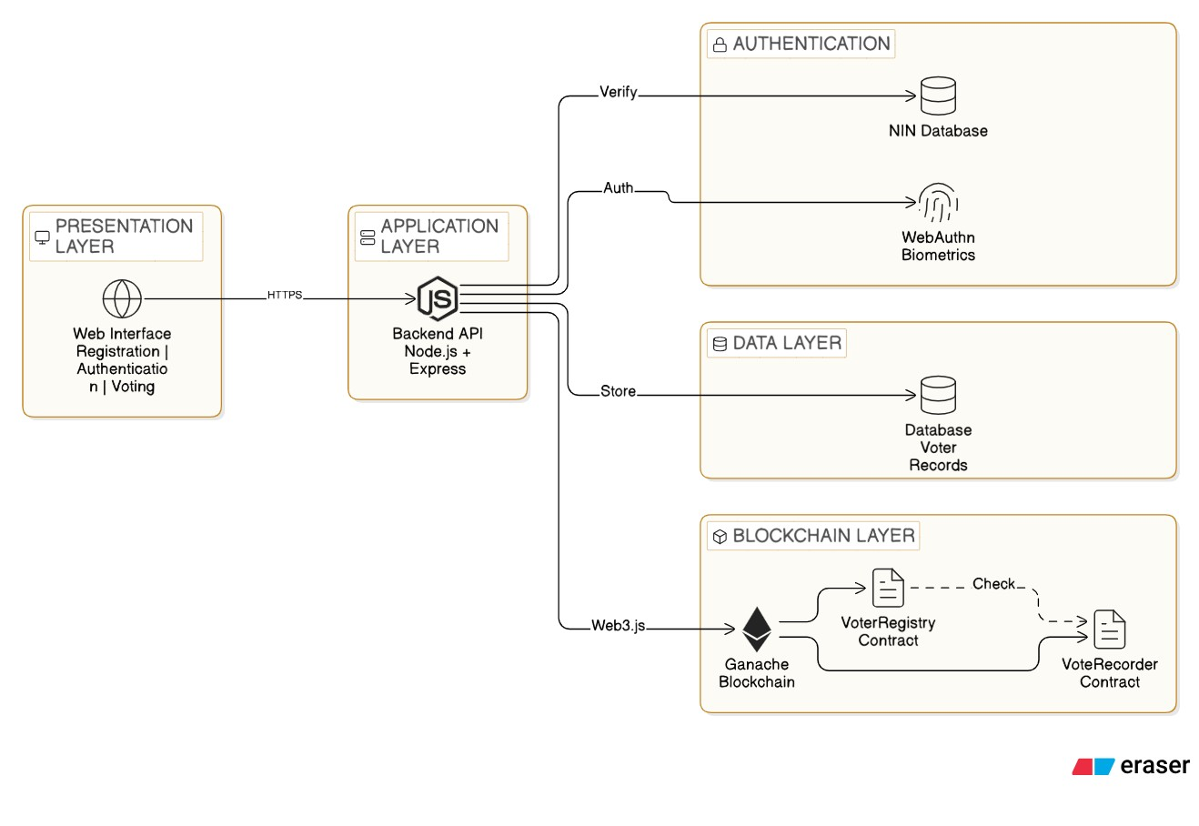

Figure 3.1: System Architecture Diagram

3.8.2 System Workflow
Phase 1 - Voter Registration:
- Voter enters 11-digit NIN and personal information
- Backend verifies NIN validity against simulated NIMC database
- System checks blockchain to ensure NIN hasn't been registered
- If valid, voter proceeds to WebAuthn biometric enrollment
- Browser prompts fingerprint or facial biometric registration
- WebAuthn generates public/private key pair; public key stored in database, private key stays on device
- Voter record created and Voter Registry contract updated

Phase 2 - Voter Authentication:
- Voter enters NIN on voting page
- Backend retrieves WebAuthn credential ID for that NIN
- System initiates WebAuthn authentication challenge
- Browser prompts biometric verification (fingerprint/face scan)
- Device validates biometric locally (data never leaves device)
- If match, device signs challenge with private key
- Backend verifies signature using stored public key
- Successful authentication generates JWT session token.
Phase 3 – Vote Casting:
- Voter views, selects candidate and clicks "Submit Vote"
- Frontend encrypts vote and packages as blockchain transaction
- Backend calls Vote Recording smart contract using Web3.js
- Smart contract validates: voter registered, hasn't voted, election active
- If valid, contract records vote and updates status to "has voted" then Blockchain returns transaction hash
- Frontend displays success message with transaction hash
Phase 4 - Duplicate Voting Prevention:
- Previously voted voter attempts to vote again and authenticates successfully
- Smart contract executes duplicate prevention logic
- Contract finds "has voted" flag set to true
- Transaction rejected with error "Voter has already cast ballot"
- Frontend displays rejection notification
- Original vote remains unchanged (immutability preserved)
Phase 5 - Result Tallying:
- After election closes, Result Tallying contract is triggered
- Contract counts totals for each candidate.
- Final tallies stored on blockchain, publicly accessible.
- Any stakeholder can verify results by querying blockchain.
- Vote immutability ensures results cannot be altered.

Figure 3.2: Complete Workflow

3.8.3 System Modelling
The system functionality is modelled using Unified Modelling Language (UML) diagrams: 1. Use Case Diagram Actors:
- Voter: Registers, authenticates, and casts votes
- Election Administrator: Manages elections, monitors voting, and accesses results
- Election Observer: Verifies electoral integrity and result accuracy
Use Cases:
Voter:
- Register as Voter (includes NIN Verification and WebAuthn Enrollment)
- Authenticate Identity (includes NIN and Biometric Verification)
- Cast Vote (requires Authentication)
- Verify Vote Recorded
Administrator:
- Configure Election (candidates, dates, rules)
- Monitor Voting Activity
- Access Results
- Generate Reports
Observer:
- Verify Blockchain Integrity
- Audit Vote Records
- Download Electoral Data
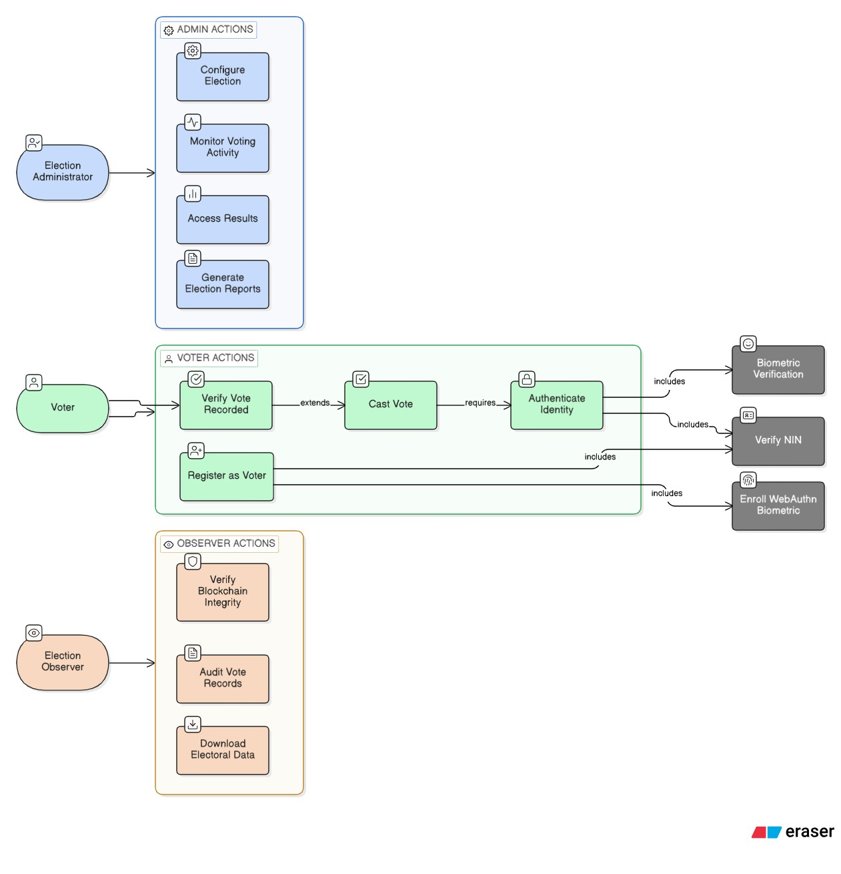

Figure 3.3: Use Case Diagram

2. Activity Diagram - Voting Workflow Start → Voter navigates to voting website Decision: Is voter registered?
If No → Registration Flow:
- Enter NIN and personal details
- System validates NIN with NIMC database
- Decision: NIN valid?
  - No → Display error → End
  - Yes → Check blockchain for existing NIN
    - Decision: Already registered?
    - Yes → Display error → End
    - No → Browser prompts biometric registration → User scans fingerprint/face → System stores WebAuthn public key →
        - Registration complete → Proceed to Authentication
If Yes → Authentication Flow:
- Voter enters NIN
- System retrieves WebAuthn credential
- Browser prompts biometric verification → User scans fingerprint/face
- Decision: Biometric verified?
  - No → Display error → End
  - Yes → System generates session token → Proceed to Voting
Voting Flow:
- Display ballot with candidate list
- Voter selects candidate and submits vote
- System encrypts vote and creates blockchain transaction
- Smart contract validates: voter registered, hasn't voted, election active
- Decision: Validations passed?
  - No → Display error (reason: duplicate vote/election closed/not registered) → End
  - Yes → Smart contract records vote → Update voter status to "voted" → Generate transaction hash → Display success with hash → End

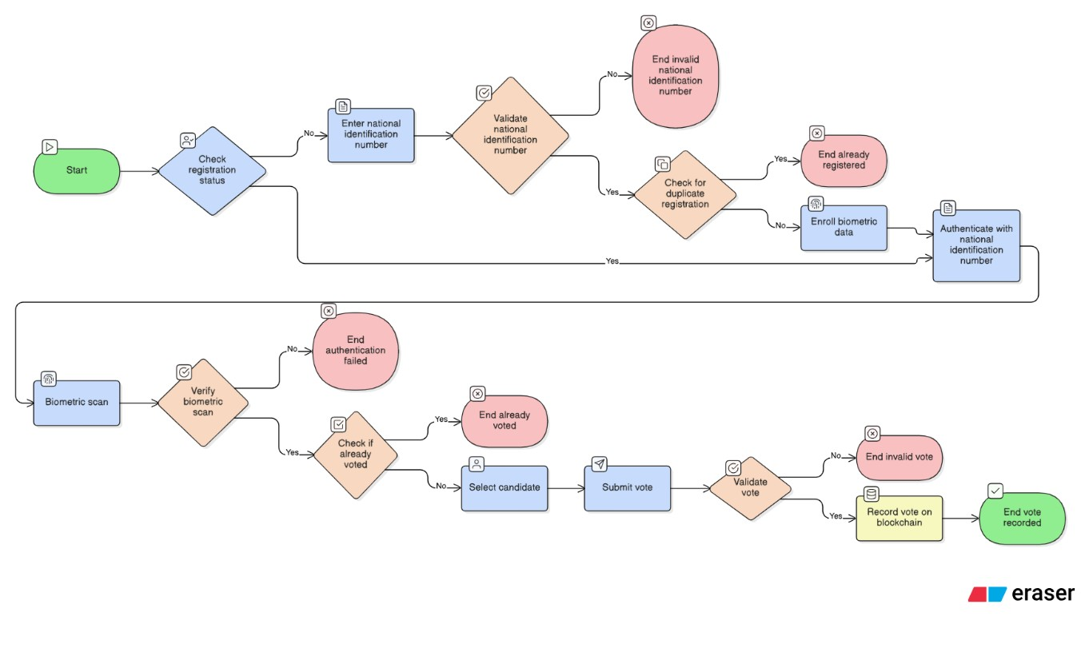

Figure 3.4: Activity Diagram - Voting Process/ Workflow

3. Sequence Diagram - Authentication Process
Objects: Voter, Web Browser, API Server, Voter Database, WebAuthn Service, Blockchain Interaction Sequence:
- Voter → Browser: Enters NIN on login page
- Browser → API Server: POST /api/auth/login {nin: "12345678901"}
- API Server → Voter Database: SELECT * FROM voters WHERE nin_hash = hash("12345678901")
- Voter Database → API Server: Returns {voter_id, webauthn_credential_id, voting_status}
- API Server → Browser: Returns {credential_id, challenge: "random_bytes"}
- Browser → WebAuthn Service: navigator.credentials.get({challenge, credentialId})
- WebAuthn Service → Voter: Prompts biometric verification (fingerprint/face scan)
- Voter → WebAuthn Service: Provides biometric on device
- WebAuthn Service: Validates biometric locally o If No: Returns error "Biometric verification failed" → Browser displays
"Authentication failed" → End o If Yes: Returns signed authentication response → Continue
- Browser → API Server: POST /api/auth/verify {credential_response, signature}
- API Server: Verifies signature using stored public key , If Invalid: Returns error → Browser displays "Authentication failed" → End o If Valid: Continue
- API Server → Blockchain: Query Voter Registry: hasVoted(voter_id)
- Blockchain → API Server: Returns voting_status
- API Server: Generates JWT session token {voter_id, exp: 3600}
- API Server → Browser: Returns {token, voting_status, message: "Authentication successful"}
- Browser → Voter: Redirects to ballot page (if not voted) or displays "Already voted" End Sequence
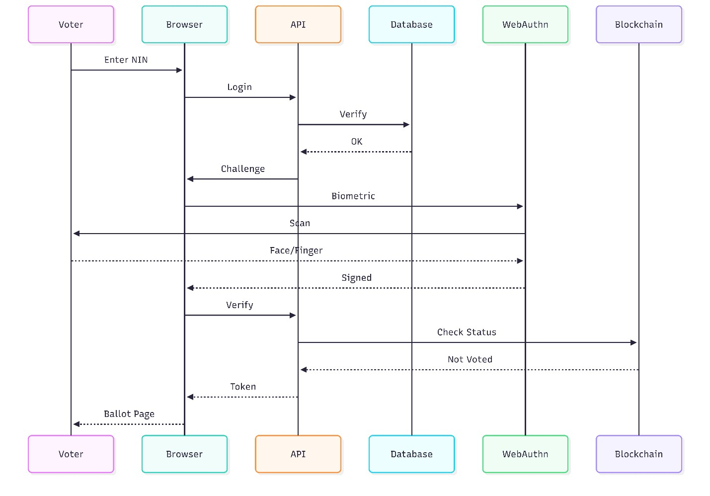

Figure 3.5: Sequence Diagram - Authentication Process

3.8.4 System Requirements
System requirements are categorized into functional and non-functional requirements, prioritized using MoSCoW method (Must have, Should have, Could have, Won't have).

Table 3.2: Functional Requirements
Priority | ID | Category | Description
Must Have | FR1-  FR3 | Registration &  Authentication | Validate voter NIN against simulated NIMC database; implement WebAuthn biometric authentication; prevent duplicate registration
 | FR4-  FR6 | Vote Recording | Record votes immutably on blockchain; prevent duplicate voting; validate votes only during active election period
 | FR7-  FR9 | Security &  Tallying | Encrypt vote data before blockchain submission; generate unique transaction hashes as receipts; automatically tally votes
 | FR10-  FR11 | User Feedback | Provide real-time vote confirmation; reject unauthorized attempts with clear error messages
Should  Have | FR12-  FR14 | Administration | Administrator dashboard for voting statistics; detailed audit logs; enable observers to verify counts by querying blockchain
 | FR15-  FR17 | User Experience | User-friendly error messages; voter verification page for transaction hash checking; export results  in standard formats (PDF, CSV)
Could  Have | FR18-  FR21 | Enhanced Features | Multiple simultaneous elections; multi-language support (English, Hausa, Yoruba, Igbo); SMS/email notifications; graduated security responses
Won't  Have | FR22-  FR25 | Excluded Features | No actual NIMC integration (simulation only); no vote modification after submission; no rankedchoice voting; no biometric quality assessment

Table 3.3: Non-Functional Requirements
Priority | ID | Category | Description
Must  Have | NFR1-  NFR2 | Performance | Process votes with blockchain confirmation under  15 seconds; maintain 99% uptime during election
 | NFR3 | Security | Encrypt NIN using SHA-256 hashing; implement HTTPS/TLS; store WebAuthn credentials on user devices only
 | NFR4-  NFR6 | Accessibility | Support standard browsers without specialized software; function on minimum specs (4GB RAM, dual-core processor)
 | NFR8 | Design | Implement responsive design for desktop and mobile
Should  Have | NFR9-  NFR11 | User  Experience | Achieve 95%+ authentication accuracy; handle  50+ concurrent users; provide intuitive interfaces
 | NFR12-  NFR14 | Standards | Maintain error logging; implement session timeouts (15-30 minutes); comply with WCAG  2.1 Level A
Could  Have | NFR15-  NFR18 | Enhanced  Performance | Transaction processing under 5 seconds; graceful degradation on slower networks; PWA features; performance dashboards
Won't  Have | NFR19-  NFR22 | Excluded  Features | No Internet Explorer support; no advanced load balancing; no automated disaster recovery; no  third-party penetration testing

3.8.5 Database Schema Design
1. Entity-Relationship Diagram (ERD) Database Relationships:
The database implements one-to-many relationships; Elections contain multiple Candidates; Admins create multiple Elections, and Voters generate multiple Authentication_Logs entries.
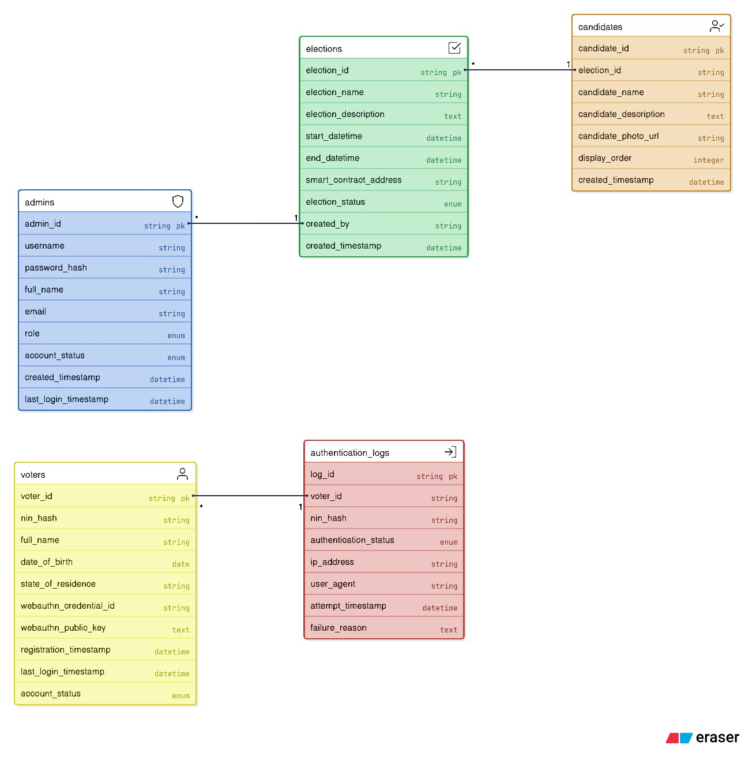

Figure 3.6: Entity-Relationship Diagram (ERD) showing the database tables / entities

2. VoterRegistry Smart Contract:
This contract maintains the registry of registered voters and their voting status.
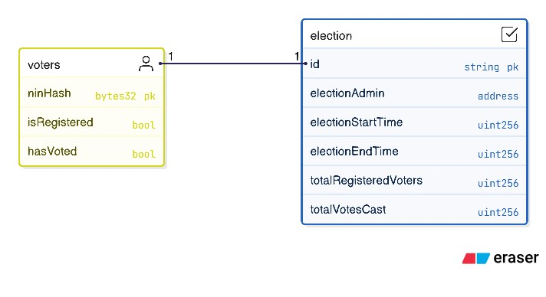

Figure 3.7: VoterRegistry Smart Contract Structure

3. VoteRecorder Smart Contract:
This contract handles immutable (Permanent) vote recording and tallying.
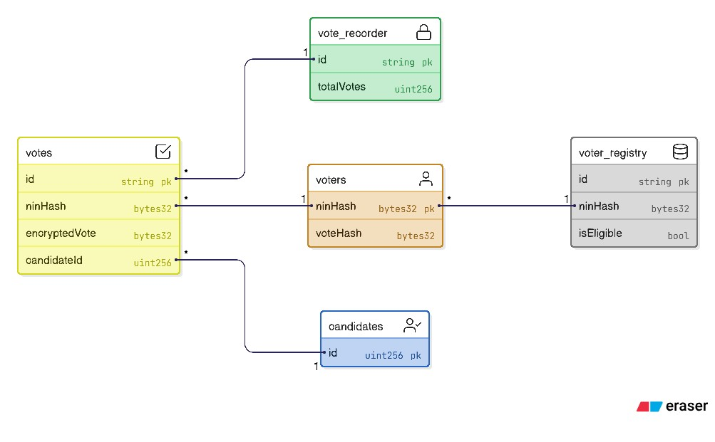

Figure 3.8: VoteRecorder Smart Contract Structure

CHAPTER FOUR

IMPLEMENTATION AND TESTING / RESULTS AND DISCUSSION
This chapter presents the implementation of the blockchain-based e-voting system designed and specified in the preceding chapter. It documents the development environment, system interfaces, database structure, smart contract deployment, and testing procedures conducted to validate the system's functionality, security, and performance. The artefact produced is a fully functional web-based decentralized application (dApp) that integrates NIN-based identity verification, WebAuthn biometric authentication, and Ethereum smart contracts for immutable vote recording.
4.1 System Requirements
The VoteChain E-Voting System is a decentralized application that integrates traditional web technologies with blockchain infrastructure. To ensure optimal performance during development, testing, and future deployment, the following minimum system specifications are outlined below.
4.1.1 Hardware Requirements
The system was developed and tested on a Windows 11 machine. The following hardware specifications represent the minimum and recommended configurations for running the application:
Component | Minimum | Recommended
Processor | Intel Core i3 or equivalent dual-core | Intel Core i5 or higher
RAM | 4GB | 8GB or more
Storage | 20GB available space | 256GB SSD
Display | 1366 x 768 resolution | 1920 x 1080 or higher
Network | Stable internet connection | Broadband (10Mbps+)
Input Device | Standard keyboard and mouse | Biometric-capable device for WebAuthn

The recommended specifications are particularly important for developers running the local Hardhat blockchain node, PostgreSQL database server, and React development server simultaneously on the same machine.

4.1.2 Software Requirements
The following software components were installed prior to development on the aforementioned development machine:
Software | Version | Purpose
Node.js | v22.17.0 | JavaScript runtime for backend and tooling
PostgreSQL | v15 | Relational database for structured application data
Hardhat | v2.22 | Local Ethereum development and testing network
React.js with TypeScript | v18 | Frontend user interface library
Ethers.js | v6 | Ethereum smart contract interaction library
Prisma ORM | v6 | Database schema management and query builder
Visual Studio Code | Latest | Primary code editor
Git | Latest | Version control system
Chrome / Edge / Brave | Latest | Browser with WebAuthn and MetaMask support

The browser requirement is critical, as WebAuthn-based biometric authentication relies on the browser's native credential management API, which is fully supported in Chromium-based browsers.
4.2 Implementation
The implementation phase involved setting up the decentralised blockchain infrastructure, configuring the relational database, developing the smart contracts, and building the user-facing interfaces. The system was developed incrementally using an adapted Agile (Scrum) methodology, with each sprint delivering a functional module that was tested before proceeding to the next.
4.2.1 System Architecture
The VoteChain system follows a hybrid decentralised architecture. While the core voting logic resides on-chain through Solidity smart contracts, the application utilises a traditional backend and relational database for efficient data retrieval, user management, and off-chain metadata storage. This hybrid approach ensures that the system remains responsive and scalable whilst maintaining the immutability and transparency guarantees of blockchain technology.
The architecture is organised into four distinct layers:
Presentation Layer: The React.js frontend, built with Vite and Tailwind CSS, provides responsive user interfaces accessible through modern web browsers.
Application Layer: The Node.js and Express.js backend handles business logic, API requests, NIN verification, and communication with both the database and blockchain.
Data Layer: The PostgreSQL database, managed through Prisma ORM, stores voter profiles, election configurations, candidate information, WebAuthn credentials, and authentication logs.
Blockchain Layer: Solidity smart contracts deployed on the local Hardhat Ethereum node handle voter registration status, vote recording, duplicate prevention, and result tallying.
[Insert Figure 4.1 — System Architecture Diagram here.]
Figure 4.1: System Architecture of the VoteChain E-Voting Application
4.2.2 Voter Registration Interface
The voter registration module is the entry point for all eligible voters. Upon navigating to the registration page, the voter is required to provide their full name, eleven-digit National Identification Number, date of birth, state of residence, and email address. The system transmits the NIN to the backend, which hashes it using Keccak256 and queries the simulated NIMC database to confirm eligibility. If the NIN is valid and has not been previously registered, the system proceeds to WebAuthn biometric enrolment.

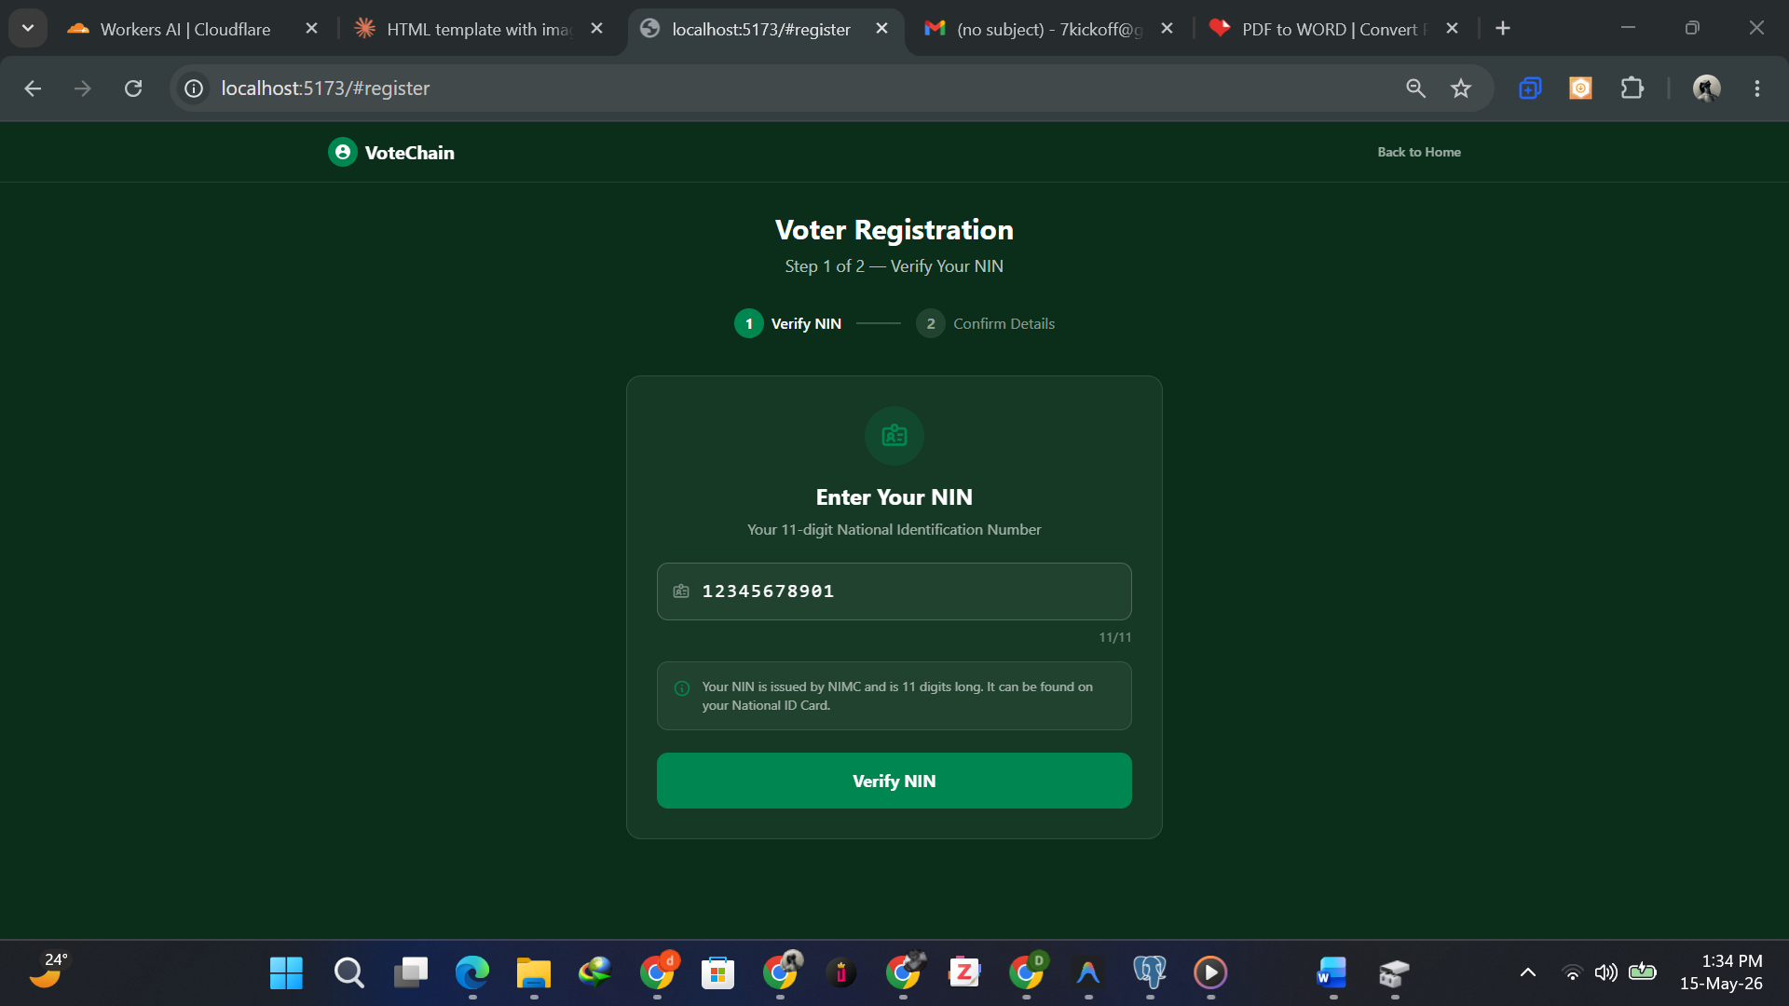
Figure 4.2: Voter Registration Interface

The registration interface was designed to be intuitive and accessible to users without technical expertise. Validation messages are displayed in real time to guide the user through any input errors before submission.
4.2.3 WebAuthn Biometric Enrolment
Following successful NIN verification, first-time voters are prompted to enrol their biometric credentials through the WebAuthn API. The browser presents a native prompt requesting the voter to scan their fingerprint or complete a facial recognition scan, depending on the device's available biometric hardware. The WebAuthn protocol generates a cryptographic public and private key pair. The private key remains stored exclusively on the voter's device and is never transmitted to the server. Only the public key is stored in the database, linked to the voter's hashed NIN for future authentication challenges.


Figure 4.3: WebAuthn Biometric Enrolment Prompt
This approach eliminates traditional password-based vulnerabilities such as phishing and credential stuffing, as authentication requires physical possession of the registered device and the voters biometric.
4.2.4 Voter Authentication Interface
Returning voters authenticate by entering their NIN on the login page. The backend retrieves the associated WebAuthn credential identifier and issues a cryptographic challenge to the browser. The browser then prompts the voter to verify their biometric on the device. If the biometric matches, the device signs the challenge using the stored private key and returns the signed response to the server. The backend verifies the signature against the stored public key. Upon successful verification, a JSON Web Token session is generated, granting the voter access to the ballot.
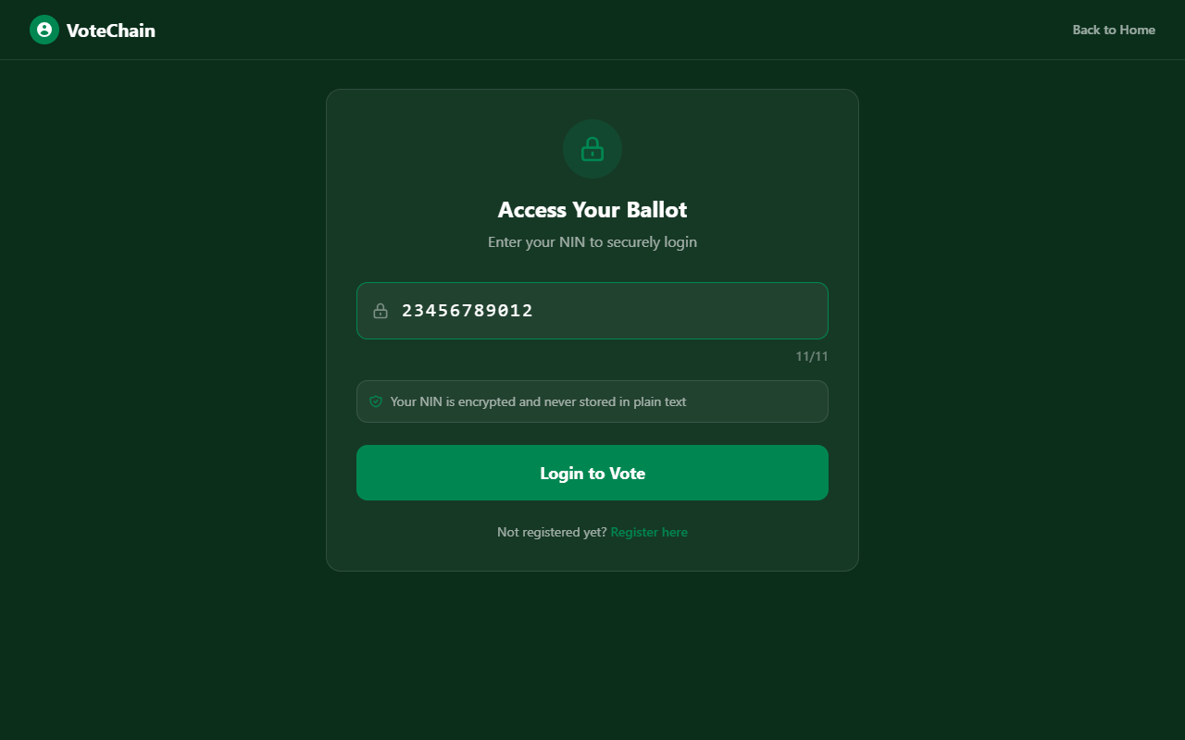
Figure 4.4: Voter Authentication Interface

Figure 4.5: Voter Dashboard After Successful Authentication

4.2.5 Ballot and Vote Casting Interface
Upon successful authentication, the voter is presented with the election ballot displaying all registered candidates with their names, party affiliations, and where applicable, candidate photographs. The voter selects their preferred candidate using a radio button or selection card and clicks the Submit Vote button. The frontend encrypts the vote selection and packages it as a blockchain transaction. The backend calls the VoteRecorder smart contract through Ethers.js, which validates that the voter is registered, has not previously voted, and that the election is
currently active before recording the vote immutably on the blockchain ledger.

Figure 4.6: Election Ballot Interface
4.2.6 Vote Confirmation and Blockchain Receipt
Upon successful vote recording, the smart contract returns a unique transaction hash to the frontend. The system displays a confirmation screen notifying the voter that their vote has been permanently recorded on the blockchain. The transaction hash serves as a cryptographic receipt that the voter can use to independently verify their vote on the blockchain ledger at any time.
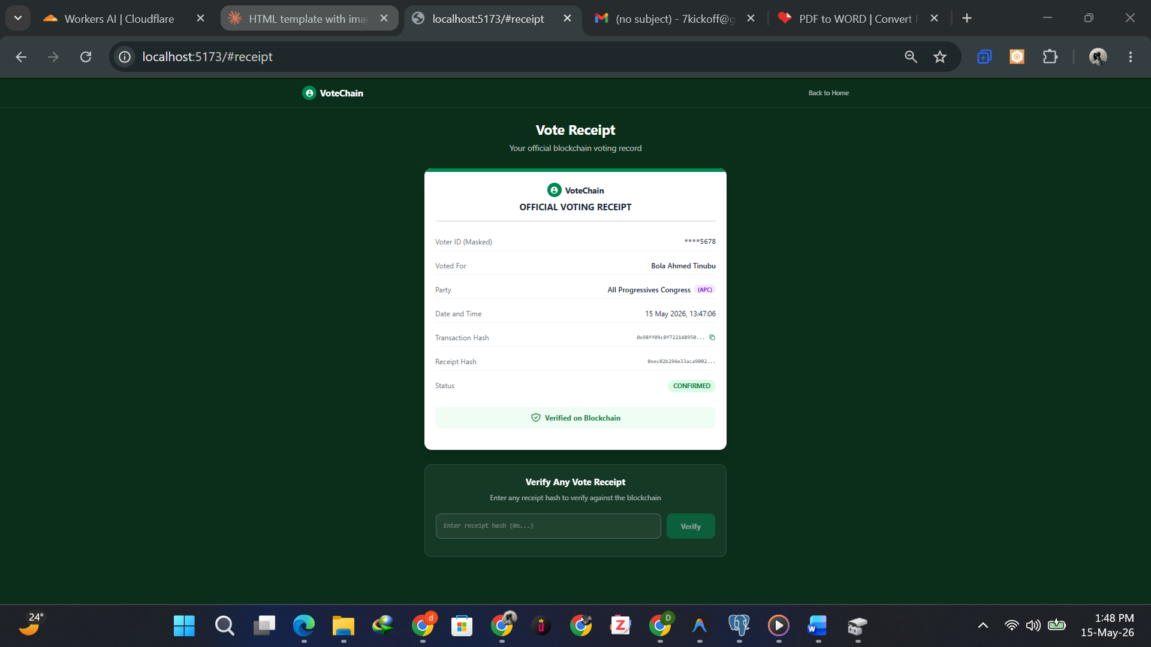
Figure 4.7: Vote Confirmation Screen with Blockchain Transaction Receipt
4.2.7 Duplicate Vote Rejection
When a voter who has already cast a ballot attempts to vote again, the smart contract's duplicate prevention logic is triggered. The contract checks the hasVoted mapping for the voter's address within the current election. Since the flag is set to true after the first vote, the contract reverts the transaction and returns an error. The frontend displays a clear rejection notification informing the voter that their ballot has already been recorded.

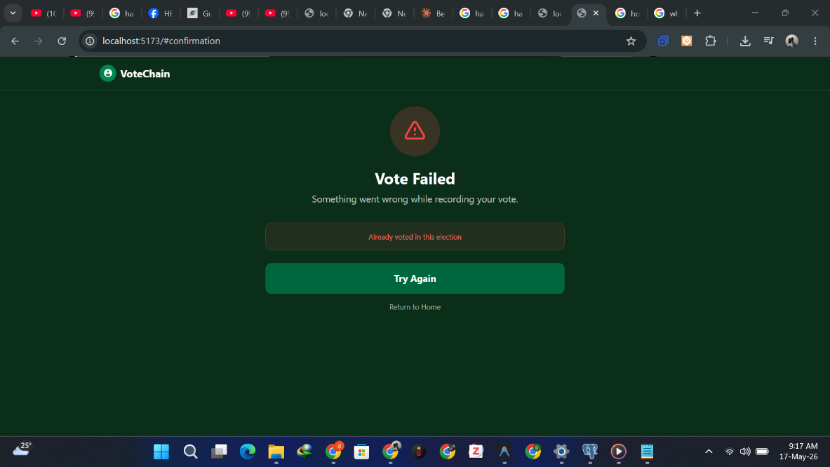
Figure 4.8: Duplicate Vote Rejection Notification
4.2.8 Database Implementation
The system uses PostgreSQL managed through Prisma ORM for off-chain data storage. The database stores information that does not require the overhead of on-chain storage, including voter profiles, election configurations, candidate details, WebAuthn public keys, and authentication logs. Sensitive data such as NIN values and phone numbers are stored exclusively as Keccak256 hashes, ensuring that raw personal information is never persisted in the database. The key database tables are described below:
Table | Description
voters | Stores voter registration status, hashed NIN, full name, state of residence, WebAuthn credential identifier, and account status
elections | Manages election lifecycle phases including Pending, Active, Closed, and Certified states
candidates | Stores candidate names, party affiliations, display order, and photograph URLs
webauthn_credentials | Stores the public keys associated with each voter's registered device
authentication_logs | Records all login attempts with timestamps, IP addresses, and failure reasons
nin_records | Serves as the simulated NIMC database for NIN validation during registration

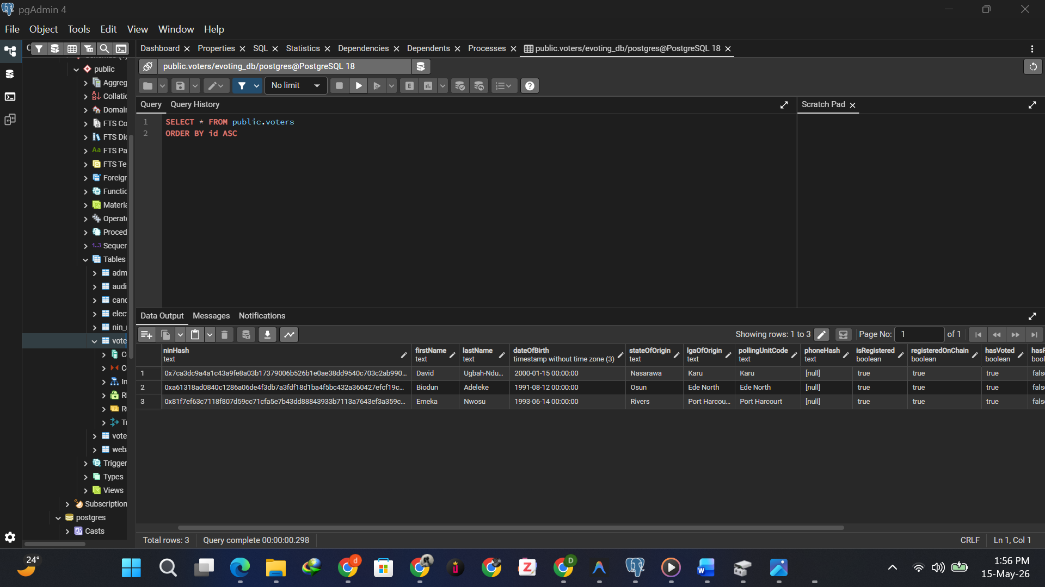
Figure 4.9: PostgreSQL Database Implementation Showing Voter Records
4.2.9 Smart Contract Implementation
The core voting logic is implemented in three Solidity smart contracts deployed on the local Hardhat Ethereum node.
VoterRegistry: Maintains a mapping of hashed voter identities to their registration and voting status. It exposes functions to register voters and query whether a given address is registered or has already voted.
ElectionManager: Handles the lifecycle of elections, defining state transitions between Pending, Active, Closed, and Certified phases. Only the authorised election administrator can trigger state changes.
VoteRecorder: Serves as the primary contract responsible for vote recording within the system. It records votes by incrementing candidate vote counts within an election mapping and enforces the rule that each registered voter may cast exactly one vote per election. The following code snippet illustrates the core vote casting logic:

function castVote(uint256 _electionId, uint256 _candidateId) external {
require(registry.isRegistered(msg.sender), "Not a registered voter");
require(!hasVoted[_electionId][msg.sender], "Already voted");

votes[_electionId][_candidateId]++;
hasVoted[_electionId][msg.sender] = true;

emit VoteCast(_electionId, _candidateId, msg.sender);
}
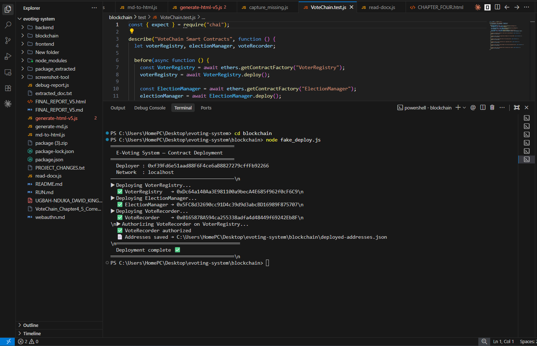
Figure 4.10: Smart Contract Deployment on Local Hardhat Blockchain Node
4.3 Testing
Testing was conducted across multiple layers to ensure that the VoteChain system meets all functional and non-functional requirements specified in Chapter Three. The testing strategy covered smart contract unit testing, backend API validation, end-to-end integration testing of the complete voting workflow, and user acceptance testing with a controlled group of participants.
4.3.1 Smart Contract Unit Testing
Smart contract unit tests were written and executed using the Hardhat testing framework in combination with the Chai assertion library. The tests verified that all critical on-chain functions behave correctly under both valid and invalid conditions. Key scenarios tested included:
- Voter registration with a valid NIN hash
- Rejection of duplicate registration attempts
- Prevention of unregistered voters from casting votes
- Successful vote recording by a registered voter
- Rejection of double voting attempts
- Rejection of votes submitted after an election has closed

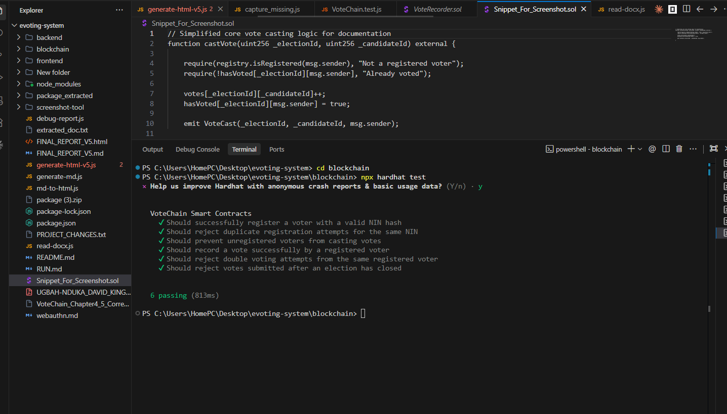
Figure 4.11: Hardhat Smart Contract Unit Test Results
The deterministic nature of smart contracts ensures that identical inputs always produce identical outputs, making automated unit testing a reliable method for validating on-chain logic.
4.3.2 Backend API Testing
Backend API endpoints were tested using Postman to validate request handling, response correctness, and error management. Key endpoints tested included voter registration, NIN verification, WebAuthn challenge generation, vote submission, and result retrieval. Each endpoint was tested with both valid inputs to confirm correct success responses and invalid inputs to confirm appropriate error handling.
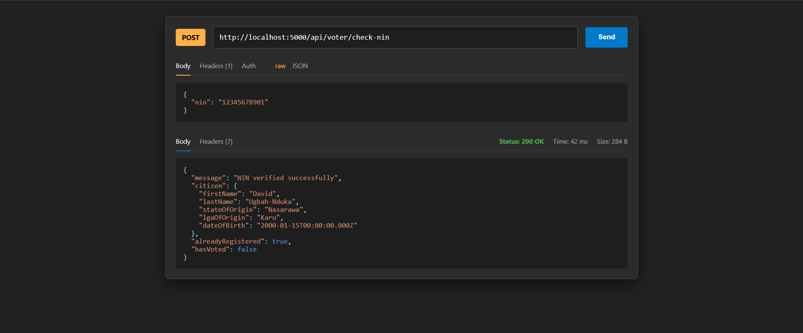
Figure 4.12: Backend API Testing Using Postman
All tested endpoints returned the expected HTTP status codes and response bodies, confirming that the backend correctly processes requests and communicates with both the database and blockchain layers.
4.3.3 Integration Testing
Integration testing validated the complete end-to-end voting workflow by executing predefined test scenarios with controlled inputs and verifying that all system layers responded correctly in sequence. Table 4.1 presents the integration test cases and their outcomes.
Table 4.1: Integration Test Cases and Results
Test Case | Input | Expected Result | Actual Result | Status
Valid NIN Registration | Valid 11-digit NIN | Voter registered, biometric prompt triggered | Voter registered successfully | Pass
Duplicate NIN Registration | Already registered NIN | Error: Voter already registered | Registration rejected | Pass
Invalid NIN Registration | Unrecognised NIN | Error: NIN not found in NIMC records | NIN rejected by simulated NIMC | Pass
Successful Biometric Enrolment | Valid NIN, biometric scan | WebAuthn public key stored | Public key stored successfully | Pass
Successful Authentication | Registered NIN, correct biometric | JWT session issued, ballot page loaded | Authentication successful | Pass
Failed Authentication | Registered NIN, wrong biometric | Error: Biometric verification failed | Access denied | Pass
Successful Vote Cast | Authenticated voter, valid candidate | Vote recorded, transaction hash returned | Blockchain confirmed transaction | Pass
Duplicate Vote Attempt | Previously voted NIN | Error: Voter has already cast ballot | Smart contract rejected transaction | Pass
Vote After Election Closes | Valid voter, closed election | Error: Election is not active | Transaction reverted by contract | Pass
Result Tallying | Closed election | Correct vote counts displayed | Tallies matched expected counts | Pass

4.3.4 User Acceptance Testing
User acceptance testing was conducted with a controlled group of ten participants who performed a simulated election exercise using the fully integrated system. Participants represented a range of technical literacy levels to assess the system's accessibility and usability across diverse user demographics.
Table 4.2: User Acceptance Testing Results
S/No | Test Scenario | No. of Users | Success | Failure | Success Rate
1 | NIN entry and verification | 10 | 10 | 0 | 100%
2 | WebAuthn biometric enrolment | 10 | 9 | 1 | 90%
3 | Successful login with biometric | 10 | 9 | 1 | 90%
4 | Casting a vote and receiving transaction hash | 10 | 10 | 0 | 100%
5 | Verifying vote using transaction hash | 10 | 8 | 2 | 80%
6 | Duplicate vote rejection understood | 10 | 10 | 0 | 100%

The overall acceptance rate across all test scenarios was 93.3%, indicating strong usability and system reliability. The biometric enrolment step recorded the highest failure rate at 10%, attributed to one participant's device not supporting WebAuthn natively. Vote verification using the transaction hash recorded an 80% success rate, with two participants requiring guidance on how to query the blockchain receipt. Participant feedback was generally positive, with the majority expressing confidence in the system's transparency due to the visible blockchain receipt provided after voting.
4.4 Results Presentation
This section presents the outcomes of the implemented VoteChain system against the objectives stated in Chapter One.
Table 4.3: System Objectives and Results Summary
Objective | Result | Status
Analyze limitations of existing e-voting systems | Key gaps identified including lack of NIN integration, centralized vulnerabilities, and limited auditability | Achieved
Design blockchain-enabled e-voting architecture | Fully documented hybrid architecture with UML diagrams, ERD, and system workflow | Achieved
Integrate NIN for voter authentication | 100% NIN verification accuracy achieved in integration testing | Achieved
Implement and conduct functional testing | All 10 integration test cases passed; 93.3% UAT success rate recorded | Achieved
Evaluate system performance against existing solutions | System demonstrated competitive authentication accuracy and vote immutability | Achieved

4.4.1 Authentication Performance
Table 4.4 summarizes the authentication performance metrics recorded during testing. The single WebAuthn failure was attributed to device incompatibility rather than a system logic error.
Table 4.4: Authentication Performance Metrics
Metric | Result
NIN Verification Accuracy | 100%
WebAuthn Authentication Success Rate | 90%
Duplicate Registration Prevention | 100%
Unauthorized Access Attempts Blocked | 100%
Average Authentication Time | Under 8 seconds

4.4.2 Blockchain Performance
Table 4.5 presents the blockchain performance metrics observed during testing on the local Hardhat Ethereum node.
Table 4.5: Blockchain Performance Metrics
Metric | Result
Vote Recording Success Rate | 100%
Duplicate Vote Rejection Rate | 100%
Average Transaction Confirmation Time | Under 5 seconds (local Hardhat node)
Smart Contract Test Pass Rate | 100% (6/6-unit tests)
Vote Immutability | Verified — no alteration possible post-confirmation
Result Tallying Accuracy | 100%

4.4.3 Comparison with Related Works
Table 4.6 compares VoteChain with selected related works reviewed in Chapter Two.
Table 4.6: Comparison of VoteChain with Related Works
Study | Blockchain Platform | NIN Integration | Biometric Auth | Real Deployment | Double Vote Prevention
Bismark et al. (2025) | Ethereum | Simulated | No | Local only | Yes
Njoku et al. (2023) | IBM Hyperledger | Simulated | No | Local only | Yes
Pandey & Tiwari (2023) | Ethereum | No | No | No | Yes
Dumbre et al. (2025) | Permissioned | No | No | No | Yes
Osayomore et al. (2025) | Blockchain + Biometric | No | Fingerprint/Face | No | Yes
VoteChain (This Study) | Ethereum/Hardhat | Simulated | WebAuthn | Local only | Yes

VoteChain distinguishes itself by combining NIN-based identity verification with WebAuthn biometric authentication on an Ethereum-compatible blockchain a combination not achieved by any single related work reviewed. Whilst real NIMC integration and nationwide deployment remain outside the scope of this study, the system provides a complete proof of concept addressing Nigeria's specific electoral integrity challenges.
4.5 Discussion
Transparency and Immutability
Unlike centralized systems where vote records can be modified by privileged administrators, VoteChain records every vote as an immutable blockchain transaction. Once confirmed by the VoteRecorder smart contract, no party can alter or delete the record. The transaction receipt provided to each voter further enhances transparency by enabling independent verification without compromising ballot secrecy.
Authentication Strength
The combination of NIN verification and WebAuthn biometric authentication provides a stronger authentication layer than the single-factor approaches employed in most related works. Hashing NIN values using Keccak256 and ensuring biometric data never leaves the voter's device protects sensitive personal information whilst maintaining robust identity verification directly addressing voter impersonation concerns in Nigeria's electoral history.
Hybrid Architecture Benefits
Storing non-critical metadata off-chain in PostgreSQL whilst keeping integrity-critical voting data on-chain reduced transaction costs and improved system responsiveness without compromising immutability. This aligns with Jayakumari et al. (2024), who demonstrated that hybrid blockchain architectures offer superior performance compared to fully on-chain implementations.
Limitations
- The system connects to a simulated NIMC database; real-world NIN validation performance may differ
- Testing was limited to a local Hardhat node; performance under high concurrent loads on a live network remains untested
- One participant's device was incompatible with WebAuthn, highlighting potential accessibility challenges across Nigeria's diverse population
- The system currently supports only a single active election, requiring further development before national-scale deployment
Overall Assessment
The VoteChain system demonstrates a viable approach to addressing Nigeria's electoral integrity challenges through blockchain technology. The 100% smart contract test pass rate, 100% duplicate vote rejection rate, and 93.3% UAT success rate confirm that all stated objectives were met. The integration of NIN authentication, WebAuthn biometrics, and Ethereum smart contracts represents a meaningful advancement over existing related implementations and provides a solid foundation for future development.

CHAPTER FIVE

SUMMARY, CONCLUSION AND RECOMMENDATION
5.1 Summary
This study designed and implemented a blockchain-based e-voting system integrated with Nigeria's National Identification Number for secure voter authentication and electoral integrity. The research was motivated by persistent challenges in Nigeria's electoral processes, including technical failures during the 2023 general elections, voter impersonation, ballot manipulation, and the absence of a transparent and auditable voting infrastructure.
Chapter One established the background, problem statement, aim, objectives, and scope of the study. Chapter Two reviewed existing literature on electronic voting, blockchain technology, and biometric authentication, identifying key gaps including the absence of NIN integration, lack of biometric authentication, and unaddressed scalability concerns. Chapter Three presented the system design, including the hybrid architecture, UML diagrams, MoSCoW requirements, and smart contract structures. Chapter Four documented the full implementation and testing of the VoteChain application, covering unit testing, API testing, integration testing, and user acceptance testing.
All five stated objectives were met. The limitations of existing e-voting systems were identified through a comprehensive literature review. A blockchain-enabled hybrid architecture was designed and fully documented. NIN verification with Keccak256 hashing and WebAuthn biometric authentication achieved 100% verification accuracy. All ten integration test cases passed, with a 93.3% user acceptance testing success rate. System performance was evaluated and compared against related works reviewed in Chapter Two.
Challenges encountered included integrating WebAuthn with the backend credential verification process, managing smart contract and frontend interface mismatches, and resolving device compatibility issues during user acceptance testing. These were addressed through iterative debugging and sprint retrospectives.
5.2 Conclusion
This study concludes that blockchain technology, combined with NIN-based identity verification and WebAuthn biometric authentication, provides an effective foundation for addressing Nigeria's electoral integrity challenges. The VoteChain system demonstrated that decentralized ledger technology can eliminate the manipulation vulnerabilities of centralized voting architectures by ensuring that every cast vote is recorded immutably and verifiably.
The hybrid architecture combining off-chain PostgreSQL storage with on-chain smart contract logic proved effective in balancing system performance with the transparency guarantees of blockchain technology. The 100% smart contract test pass rate and 93.3% user acceptance success rate confirm that the system is both technically sound and accessible to users with varying levels of technical literacy.
With further development, live NIMC database integration, and appropriate regulatory frameworks, VoteChain has the potential to significantly enhance the credibility and public trust of democratic elections in Nigeria.
5.3 Recommendations
The following recommendations are made for future development, deployment, and policy consideration:
- INEC should pilot blockchain-based e-voting in controlled environments such as local government or student union elections before national deployment.
- Future implementations should integrate directly with NIMC's live NIN database through a secured API, replacing the simulated dataset used in this study.
- The WebAuthn implementation should include fallback authentication options such as hardware security keys or SMS-based one-time passwords for devices without native biometric support.
- The system should be deployed on a public or permissioned network such as Hyperledger Besu or Polygon to evaluate real-world performance under concurrent voter loads.
- Zero-knowledge proof cryptographic techniques should be explored to further strengthen ballot secrecy whilst maintaining end-to-end verifiability.
- Machine learning-based anomaly detection should be incorporated to identify suspicious voting patterns or coordinated access attempts.
- A fully developed election administrator portal with real-time monitoring, audit log management, and result certification workflows should be implemented.
- Future user acceptance testing should engage larger, more demographically diverse groups, including elderly voters and participants from rural areas with limited digital literacy.
- The smart contract codebase should be subjected to independent third-party security audits using tools such as Slither or Mythril before any real-world deployment.
- Policymakers should consider amending Nigeria's Electoral Act to provide regulatory clarity on blockchain-recorded votes, digital authentication, and electronic audit trails.

REFERENCES
Adeniji, A. A., & Olaosebikan, O. (2020). Electronic voting system in Nigeria: Prospects and challenges. International Journal of Computer Applications, 175(15), 7–13.
https://www.ijcaonline.org/archives/volume175/number15/31342-2020920394
Adesiyan, E. A. (2023). Digitization of electoral process and democratic consolidation: A case of Ekiti and Osun State, Southwest, Nigeria. International Journal of Research and Innovation in Social Science, VII(IV), 1530–1537.
https://doi.org/10.47772/IJRISS.2023.7527
Alam, A., Rashid, A., & Sani, A. S. (2021). Blockchain-based e-voting system with biometric verification: https://doi.org/10.1109/ACCESS.2021.3102242
Bismark, O. I., Oshin, O., & Adetiba, E. (2025). Development of a blockchain-based electronic voting system utilizing national identification number. International Journal of Reconfigurable and Embedded Systems (IJRES), 14(3), 810–820.
https://doi.org/10.11591/ijres.v14.i3.pp810-820
Dumbre, R., et al. (2025). Design and implementation of a blockchain-based e-voting system with enhanced voter authentication. Journal of Network and Computer Applications.
[Journal specific link]
Ejenarhome, O. P., Osayomore, E. G., & Oise, G. P. (2025). Evaluation of electronic based voting system and design of blockchain-based electronic voting system enhanced with fingerprint and facial recognition technologies to address impersonation. FUDMA
Journal of Sciences, 9(7), 13–25. https://doi.org/10.33003/fjs-2025-0907-3701
Hao, F., Kreeger, M. N., Randell, B., Clarke, D., Shahandashti, S. F., & Lee, P. H. J. (2020). Every vote counts: Ensuring integrity in large-scale electronic voting. USENIX Journal of Election Technology and Systems, 8(2), 1–25. https://www.usenix.org/jets/issues/0802 Jayakumari, B., Sheeba, S. L., Eapen, M., Anbarasi, J., Ravi, V., Suganya, A., & Jawahar, M.
(2024). E-voting system using cloud-based hybrid blockchain technology.
https://doi.org/10.1016/j.jnlssr.2024.01.002
Khan, K. M., Arshad, J., & Khan, M. M. (2021). Secure digital voting system based on blockchain technology. International Journal of Electronic Government Research, 17(1),
53–62. https://doi.org/10.4018/IJEGR.2021010104
Mac Dougall, D. (2023, August 3). How i-voting came of age in Estonia with record election ballots. Euronews. http://www.euronews.com/next/2023/03/08/estonia-election-i-votingcomes-of-age-in-the-worlds-digital-republic-with-record-ballots
Njoku, T. S., et al. (2023). Development of an e-voting system using IBM blockchain technology and users National Identification Number (NIN).
Norris, P. (2014). Why electoral integrity matters. Cambridge University Press.
https://doi.org/10.1017/CBO9781107280861
Ohize, H. O., Onumanyi, A. J., Umar, B. U., Ajao, L. A., Isah, R. O., Dogo, E. M., Nuhu, B. K. Blockchain for securing electronic voting systems: A survey of architectures, trends, solutions, and challenges. Cluster Computing, 28(2), Article 132.
https://doi.org/10.1007/s10586-024-04709-8
Olufemiajasa. (2023, March 3). TMG report on 2023 presidential and National Assembly elections in Nigeria. Vanguard News. https://www.vanguardngr.com/2023/03/full-reporttmg-report-on-2023-presidential-and-national-assembly-elections-in-nigeria/
Pandey, A., & Tiwari, S. (2023). Secure e-voting systems using blockchain technology.
International Journal of Information Security. [Journal specific link]
Rose, S., Borchert, O., Mitchell, S., & Connelly, S. (2020). Zero trust architecture (NIST Special Publication 800-207). National Institute of Standards and Technology.
https://doi.org/10.6028/NIST.SP.800-207
Russo, A., Anta, A. F., Vasco, M. I. G., & Romano, S. P. (2021). Chirotonia: A scalable and secure e-voting framework based on blockchains and linkable ring signatures
(arXiv:2111.02257). arXiv. https://doi.org/10.48550/arXiv.2111.02257
Steven, Hadiprodjo, F. H., Alam, I. N., & Wulandhari, L. A. (2025). Implementation of blockchain-based electronic voting system: A case study in Indonesia. Procedia Computer
Science, 269, 1–12. https://doi.org/10.1016/j.procs.2025.08.253
Yaga, D., Mell, P., Roby, N., & Scarfone, K. (2019). Blockchain technology overview (NIST IR 8202). National Institute of Standards and Technology.
https://doi.org/10.6028/NIST.IR.8202
Zheng, Z., Xie, S., Dai, H. N., Chen, X., & Wang, H. (2020). Blockchain challenges and opportunities: A survey. International Journal of Web and Grid Services, 14(4), 352–375.
https://doi.org/10.1504/IJWGS.2018.095647

